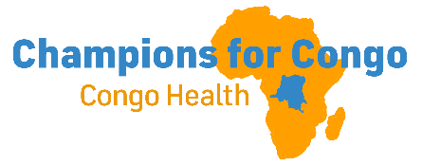CONGO CONNECT September 2, 2026
NUNDU SCHOOL OF NURSING EXPANSION
MATERNAL-CHILD HEALTH A PRIORITY
In our September 18, 2024, newsletter, we reported on the urgent need to build additional classrooms to expand and strengthen Nundu’s capacity for training midwives to improve health outcomes. Maternal and child health remains a critical concern, with high numbers of maternal and child deaths reported in all healthcare facilities. The Nundu School of Nursing was established in 1987 to train nurses for Nundu Deaconess Hospital (NDH). A four classroom, offices, and library complex built in 2010 initially served the school well, but with the expanded mission of training midwives more space was needed.

BUTTERFIELD FOUNDATION FUNDING
Because of the need for qualified midwives Nundu began a program to train midwives in 2016, but no additional classrooms were added. In 2024 our grant application to Butterfield Foundation for $64,000 to add urgently needed classrooms and office space was approved. Construction began in 2025 after a three-month delay due to the M23 takeover of Bukavu, the provincial capital of South Kivu.
CONSTRUCTION COMPLETED
With Paul Ikocha as our architect, engineer, and contractor, the Nundu midwives building project was completed in August. The project included site preparation and production of compressed interlocking sand-clay-cement blocks, foundation and superstructure, roofing and ceiling, installation of doors, windows and ventilation units, wall and floor finishes, electrical and plumbing installations, painting, sidewalks and steps, and septic tank.
The project was completed despite the initial delay in early 2025 and an approximately four-month interruption caused by the deterioration of security in eastern DRC. Construction was suspended in mid-December 2025 after Uvira fell under M23 control and resumed on March 23, 2026 after access through Uvira and the DRC-Burundi border was restored. Through contingency planning, strategic procurement, flexible work arounds, and active project management, the team successfully overcame the resulting security, logistical, economic and labor challenges and brought the project to completion.
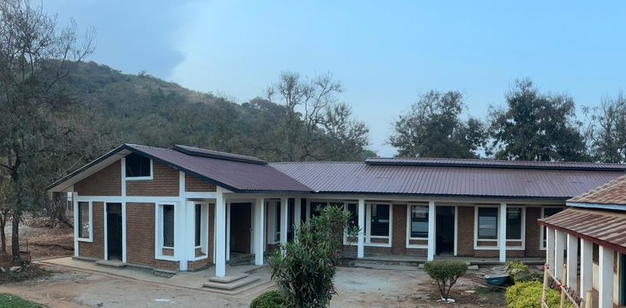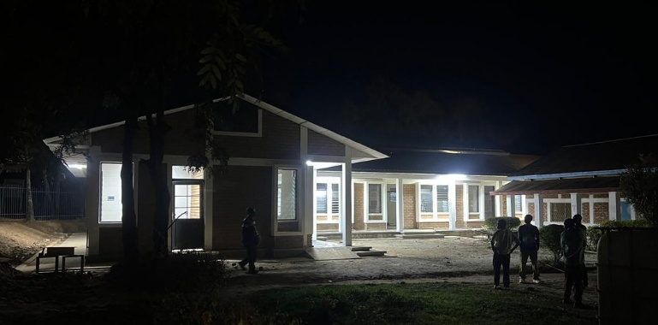
The project also faced poor road conditions, exchange-rate pressure, a fuel crisis, higher transport and material costs, difficulties accessing construction funds, and a shortage of trained labor following displacement of workers. Some project technicians sought refuge in camps in Bujumbura, while replacement technicians were sourced from Baraka, Uvira and other accessible areas. The four classrooms and office space are now ready for final inspection and formal handover for the new school year, 2026-2027.
ONGOING CONGO REALITIES
Decades of conflict in Eastern Congo have impacted all sectors of life, resulting in a fragile economy and poor health for so many people. Civil unrest has continued and threatened the successful completion of this project. Epidemic and endemic diseases slow efforts to improve health outcomes. Even today the Ebola outbreak has impacted the delivery of healthcare with women and children the most affected. Thankfully, Nundu has not yet been impacted by this latest epidemic.

SUMMARY OF IMPACT
Nundu School of Nursing is addressing the crisis in healthcare by training qualified midwives. Programs to improve retention of students from year 1 to year 4 have been put into place. We are taking steps to improve academic outcomes and graduation rates. With well trained midwives assigned to the health centers we will see a decrease of maternal-child morbidity/mortality rate in the Nundu Health Zone. Over the next five years we expect to see 70 midwife graduates. We will improve retention of students as well as see improvement of academic performance by providing classrooms dedicated to the midwife tack. (Construction team below)
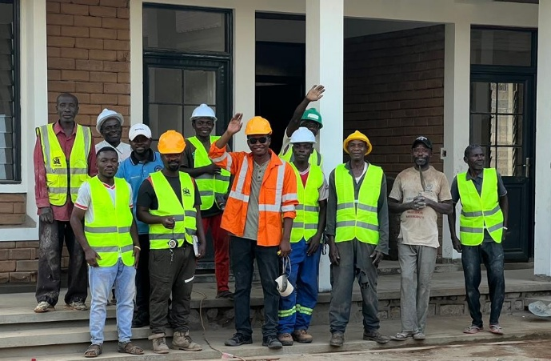
Yes, construction of the midwife classroom building will enable ITM Nundu to provide the learning environment for nurses and midwives who will provide holistic care which is transforming. Adding four classrooms and two offices will allow space dedicated to the midwife track, both for lectures and facilitating after-hours study and tutoring.

INTRODUCING PAUL IKOCHA
Please meet Paul Ikocha, engineer, architect, builder, entrepreneur.
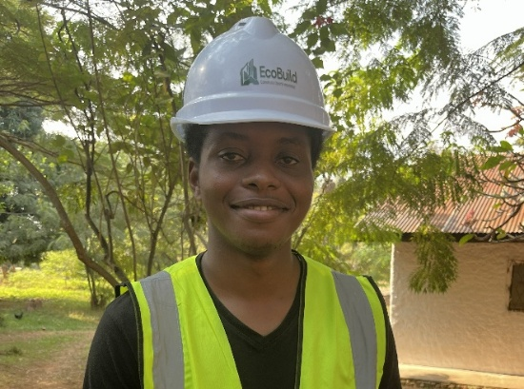
I first met Paul during our Nundu visit in July of 2023. We were preparing to host a team from the U.S. who were coming to Nundu to upgrade the station’s solar installation and to correct problems with the electrical grid on the station. An electrician was needed to wire a residence as well as assist with other tasks. To fill the gap, the Lord provided a young man, Paul Ikocha, who had received technical training in secondary school as an electrician.
I learned that Paul with two other Congolese men had established a firm registered in the DRC as ECOBUILD. He had just graduated from the Anglican University in Uganda with a degree in engineering. In his classes he was also introduced to architecture and project management. Paul was engaged to prepare plans for the Nundu School of Nursing Expansion. With these plans we were successful in receiving a $64,000 grant from Butterfield Foundation in 2024.
Paul was ready to begin construction in January of 2025, but war came to our region that very month. Because of the war, he had limited access to his home office in Bukavu. His focus was then Nundu. At Nundu he built a guest house, using innovative brick making technology - sand, clay, and cement compressed into interlocking blocks. He then used this same technology in the Nundu School of Nursing project
Over the last 18 months, Paul has been overseeing the School of Nursing project. He is gifted as an engineer and architect, creative as a project manager, and spiritually discerning in leading his team. We thank God for sending him to us.
_________________________________________________

Thank you for your prayers and financial support. Please continue to pray for peace and control of the Ebola epidemic. All contributions to support healthcare ministries in the DRC and the Nundu School of Nursing are received by the Butterfield Foundation. To make donations go to our website: www.congohealth.org or mail checks to Butterfield Foundation, 8308 N May, Suite 200, Oklahoma City, OK 73120. You may also use this QR Code.
With gratitude and hope, Tim Kratzer

