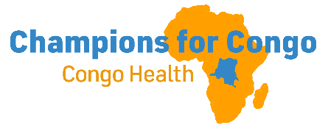
This Ebola outbreak is now the deadliest ever in DRC as death rate reaches 46%. Roughly 100 new cases are reported each day.
CONGO CONNECT August 18, 2026
EBOLA UPDATE: DRC FACES ITS DEADLIEST OUTBREAK IN HISTORY
The Democratic Republic of the Congo (DRC) is facing its deadliest Ebola outbreak ever recorded.
As of August 16, 2026:
• 4,945 confirmed cases
• 2,325 deaths
• 101 new confirmed cases reported in the previous 24 hours
This outbreak has surpassed the 2,299 deaths recorded during the 2018–2020 Ebola outbreak in the DRC. What makes this outbreak different? The outbreak is caused by Bundibugyo virus, a species of Ebola for which there is currently no approved vaccine or specific treatment. Experimental vaccines and treatments are being evaluated.
The outbreak was officially declared on May 15, 2026, and has spread to six provinces in the DRC. Uganda also experienced cases linked to the outbreak, but authorities have managed to contain transmission there.
Why is the death rate so high? The reported case-fatality ratio has risen to around 46%. Experts say this does not necessarily mean the virus has become more lethal. Delayed diagnosis, limited access to healthcare, weak surveillance and people being identified very late in the illness are major factors.
Ebola spreads primarily through direct contact with the blood or other bodily fluids of an infected person or someone who has died from the disease. This is a serious public-health emergency, and rapid detection, isolation, supportive care, safe burials and community cooperation remain critical to stopping transmission.
This is an evolving outbreak. Numbers can change as health authorities verify and report new cases.
#Ebola #DRC #PublicHealth #EbolaOutbreak #GlobalHealth (Lande Ifedayo)
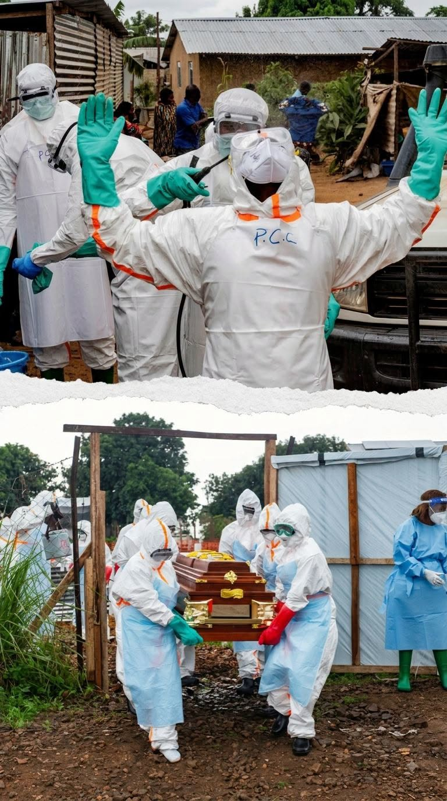
NO SIGNS OF ABATING
In the latest Disease Outbreak News update from the WHO, the agency said the outbreak was showing no signs of abating.
“During the most recent reporting week (epidemiological week 32, 3 to 9 August 2026), the highest weekly number of reported cases (579) and deaths (304) were recorded, highlighting the exceptional pace of transmission,” the WHO said. As of August 12, 100 new cases were recorded every 24 hours.
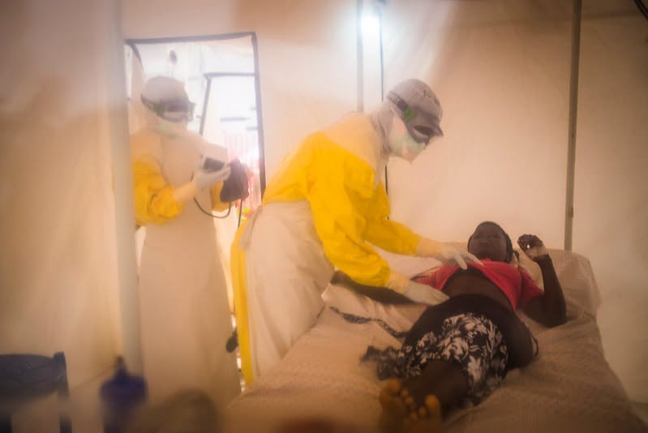
Infections among health workers continue, the WHO said. with at least 155 confirmed cases, including 45 deaths (CFR, 29%) and 68 recoveries since beginning of the outbreak.
The largest Ebola outbreak ever recorded was a 2014-16 outbreak in West Africa, which killed 11,325 over two years. The current outbreak is moving at a faster pace than that outbreak, however, and with no effective vaccine or therapeutics against the Bundibugyo strain, experts warn it could become the world’s deadliest in a matter of months.
Today (August 18) the International Health Regulations Emergency Committee will hold its second meeting since May regarding the outbreak.
Based on a report posted by Stephanie Soucheray, MA, UNIVERSITY OF MINNESOTA,
Ebola outbreak now deadliest ever in DR Congo as death rate reaches 46%

CALL TO PRAYER
While there have been no cases of Ebola reported in or near Nundu, your prayers on behalf of Eastern Congo are urgently needed. We reported August 1: “The number of cases is increasing exponentially, with a doubling every 20 days. More than 3500 people are now reported to be infected. With a case fatality rate of almost 45%, the total number of deaths is now 1,536. Fifty people die of Ebola every day.”
Nundu Deaconess Hospital and its health centers continue to provide critically needed services, not knowing when a case of Ebola might present.
- Pray for the safety of healthcare workers.
- Pray that the spread of the virus will be controlled.
- Pray that Ebola will not spread south to Nundu, which is in the South Kivu Province..
- Pray for the wisdom of the medical staff as they direct the response to this epidemic which has spiraled out of control.
THANK YOU
The ministry of Nundu Deaconess Hospital continues because of your prayers and faithful financial support. Your generosity enables us to encourage the medical staff with salary supplements, purchase medications and supplies, and provide scholarships for midwives and nursing students.
Thank you for your prayers, that the Ebola epidemic will be controlled and peace will come to Eastern Congo. As reported previously , the September trip Ken and I had planned to the DRC is on hold because of the US State Department restrictions on travel related to Ebola. Pray that we will be able to reschedule our visit in accordance with the Lord’s plan.

Again, thank you for your financial support. All contributions to support healthcare ministries in the DRC are received by the Butterfield Foundation. To make donations go to our website: www.congohealth.org or mail checks to Butterfield Foundation, 8308 N May, Suite 200, Oklahoma City, OK 73120. You may also use this QR Code.
With gratitude and hope, Tim Kratzer

