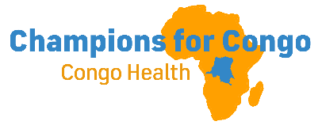CONGO CONNECT June 17, 2026
Update from Eastern DRC
Ongoing conflict and now an Ebola epidemic in Ituri, the province north of North Kivu Province, continue to impact Eastern Congo. Though the healthcare infrastructure is compromised by civil conflict and withdrawal of USAID funding, humanitarian agencies have stepped up to fill the gap. Samaritan’s Purse has established Ebola treatment centers at Nyankunde Hospital and in Bunia, the provincial capital of Ituri. Doctors Without Borders provide treatment and resources from the provinces of Ituri to South Kivu. WHO is also present on the ground, working in collaboration with CDC Africa based out of Kinshasa. Support of legacy mission hospitals such as Nyankunde Hospital in Ituri and Nundu Deaconess Hospital in South Kivu remains integral in maintaining a fragile healthcare system. While 800 cases are now reported with 200 deaths, pray that this epidemic can be arrested and lives will be saved.
Nundu Deaconess Hospital Updates
What is the status of Ebola in South Kivu and what is our state of preparedness to deal with Ebola? Though Nundu is 100’s of miles away from the epicenter of the Ebola epidemic in Ituri, the hospital staff remain vigilant. There are a few reported cases in South Kivu, but so far the virus seems to be contained. However, the Gould Family Foundation (GFF) with whom we partner had staff in Uganda who had contact with Ebola and had to go into quarantine. For this reason, GFF encouraged us to be prepared in case there would be spread of the virus to Nundu. We tried to access PPE in Burundi but were not given permission to export to the DRC. Purchasing PPE in Uganda is not an option because the route between Bukavu and Uvira is closed and the indirect route is too long. However, a private pharmacy in Uvira was able to provide the PPE needed. An order was placed and the requested PPE has been shipped to Nundu.
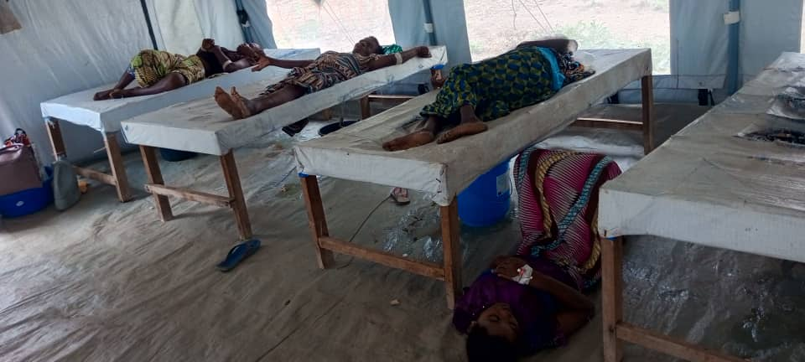

Providentially there is an isolation facility previously built to care for cholera patients at Nundu now staged to provide for the care of Ebola patients. Training has been provided by Jali Afya staff and Nundu Health Zone staff. With the Gould Family Foundation taking the lead in covering half the cost, Champions for Congo is covering the balance of $575. Your ongoing, generous support has made this possible.
ITM Nundu (Nundu School of Nursing)
Construction continues with the finishing phase in sight. The roofing structure and roofing are now being installed. The final phase will be the installation of doors, windows, and finishing of the walls. To complete construction, $12,000 is needed to do the inside finishing, but the current balance is only $2500. Because we have a balance in our general fund, we can advance $10,000. We are in the process of recovering $25,000 frozen in the bank since the onset of the war, January 2025. Pray that we will be able to recover these funds.
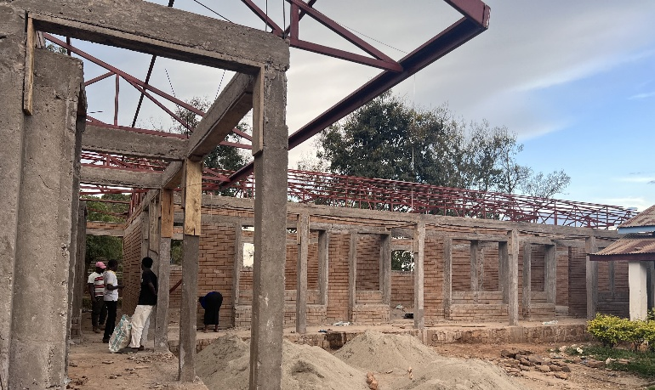
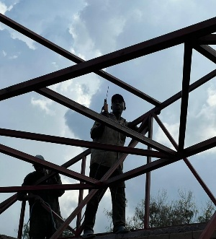
The roofing structure and roofing are now being installed. The final phase will be the installation of doors, windows, and finishing of the walls.
To finish the school year strong, we are responding to a request for assistance in providing a noon meal for 180 students and 20 staff. Thank you for your support which has enabled us to respond to this request.

All contributions to support healthcare ministries in the DRC are received by the Butterfield Foundation. To make donations go to our website: www.congohealth.org or mail checks to Butterfield Foundation, 8308 N May, Suite 200, Oklahoma City, OK 73120. You may also use this QR Code. Thank you for your generosity. Tim Kratzer
The isolation facility previously built to care for cholera patients at Nundu.

