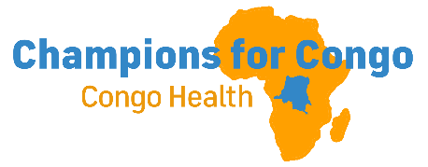CONGO CONNECT
August 1, 2026
EBOLA UPDATE
Eastern Congo continues to face the ravages of the Ebola epidemic. One week ago, we reported that more than 1,000 had died of Ebola in eastern DRC, with more than 2,500 cases reported. The number of cases is increasing exponentially, with a doubling every 20 days. More than 3500 people are now reported to be infected. With a case fatality rate of almost 45%, the total number of deaths is now 1,536. Fifty people die of Ebola every day.
Aid agencies such as Samaritan’s Purse, Doctor’s Without Borders, and the WHO are trying to stem the tide by setting up field hospitals. Currently there are more than 800 Ebola patients in isolation, with 626 discharged after recovering. Even with these efforts to provide treatment and attempts to inform the population about measures to control the spread, there is a lack of trust in the healthcare system. Ongoing civil conflict and food insecurity makes this crisis even more dire.
We continue to call on you to join us in prayer to stem the tide of this horrific epidemic which is spreading more rapidly than any previous Ebola outbreak.
- Pray for the safety of healthcare workers.
- Pray that the spread of the virus will be controlled.
- Pray that Ebola will not spread south to Nundu, which is in the South Kivu Province..
- Pray for the wisdom of the medical staff as they direct the response to this epidemic which has spiraled out of control.
Your prayers are urgently needed.

FACING ADVERSITY
The completion of the Nundu School of Nursing construction project is now projected for August 13-20, even in the face of adversity which has caused multiple delays.
The project is now in its final phase. The substructure, superstructure, roof structure, roof covering, wall plastering, and installation of doors, windows, and ventilation units have been completed or substantially completed. Current activities focus on ceiling installation, floor finishes, painting, glazing, electrical and plumbing installations, and completion of sidewalks and steps.
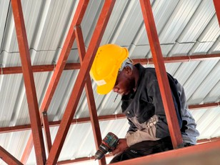
The project has experienced delays because of ongoing civil conflict, closure of borders, and interruptions of supply chains. The project also faced exchange-rate pressure, a fuel crisis, higher transport and material costs, and a shortage of trained labor following the displacement of technicians. Some project technicians were forced to seek refuge in camps in Bujumbura, while replacement technicians were sourced from accessible towns and villages. The project team managed these pressures through the careful use of contingency funds, strategic procurement, work sequencing and active site management.
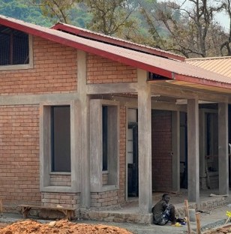
The combined impact of these challenges was managed through contingency funding, strategic planning, careful scheduling, consolidated procurement and transport, and the recruitment of replacement skilled labor. These measures enabled the project to continue advancing without compromising the priority completion activities.
In summary, the construction team with Paul Ikocha’s leadership demonstrated resilience by remobilizing promptly after the reopening of the border with Burundi and advancing several finishing activities simultaneously. The major structural works are complete, and the project is now focused on final finishes, services, glazing and external works. The team remains committed to delivering a safe, functional and durable facility within the projected completion window.
As reported by Paul Ikocha, Civil Engineer
FINISHING THE COURSE
On June 22, 2026, the national jury for nursing and midwife students began at Nundu. This jury oversees the final exams offered after four years of study. Nundu School of Nursing received 141 candidates, coming from six schools in the territory, an amazing gathering considering ongoing conflict.
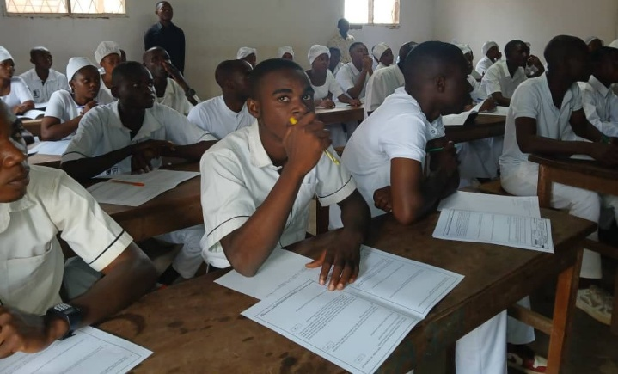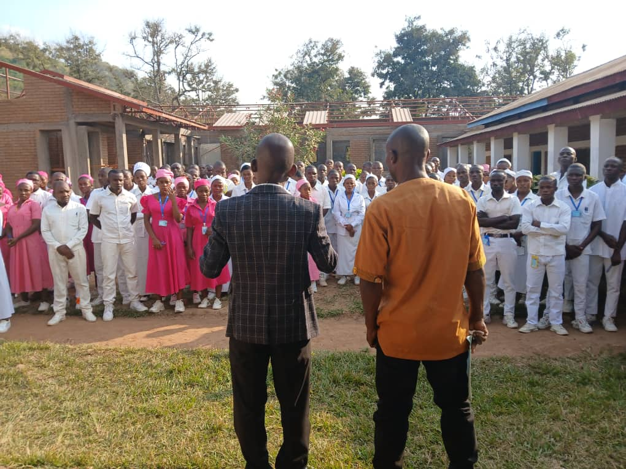
We are also pleased to report that, compared to the academic year 2024 – 2025, we have seen an improvement in the results of those students who benefited from scholarships for the 2025 – 2026 school year. The results of final exams were announced on Thursday, July 02, 2026, ending the school year. We sincerely thank all our partners for the constant support of different kinds for our institution. May our God bless them a hundredfold.
As reported July 03, 2026, Kayande Kabiona, Nundu School of Nursing Director

THANK YOU
Your generosity enables us to encourage the medical staff with salary supplements, purchase medications and supplies, and provide scholarships for midwives and nursing students.
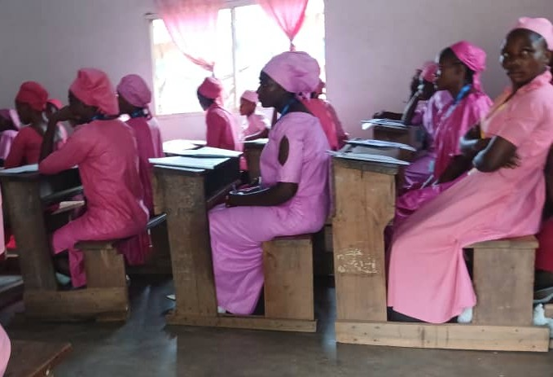
Thank you for your prayers, that the Ebola epidemic will be controlled and peace will come to Eastern Congo.
My son Ken and I had planned a September trip to the DRC, but because of Ebola the US State Department placed restrictions on travel. Pray that we will be able to reschedule our visit soon.

All contributions to support healthcare ministries in the DRC are received by the Butterfield Foundation. To make donations go to our website: www.congohealth.org or mail checks to Butterfield Foundation, 8308 N May, Suite 200, Oklahoma City, OK 73120. You may also use this QR Code. Thank you for your generosity. Tim Kratzer

