 Congo Connect May 29, 2026
From FMWM HOTLINE
Ebola cases and deaths continue to rise in the Democratic Republic of Congo as efforts are underway to contain the outbreak. Please pray:
- Communities will trust those working to help
- The people will follow safety measures to prevent further spread
- For healing for Dr. Peter Stafford, a medical missionary serving at Nyankunde Hospital in Ituri Province, who contracted Ebola while caring for a patient
- For effective plans and resources to bring a swift end to the outbreak
- For wisdom and protection for healthcare workers and officials
- For peace for all who are living in fear

Nundu Deaconess Hospital has been impacted by civil unrest and now the Ebola outbreak poses a new threat. The center of the epidemic has been identified in the Ituri Province where Bunia is the capital. There have been 220 known deaths and more than 900 cases reported. Because of the war and withdrawal of USAID funding, personal protective equipment and testing have not been adequate. How can the healthcare system be maintained in the face of conflict? How can this deadly epidemic be contained?
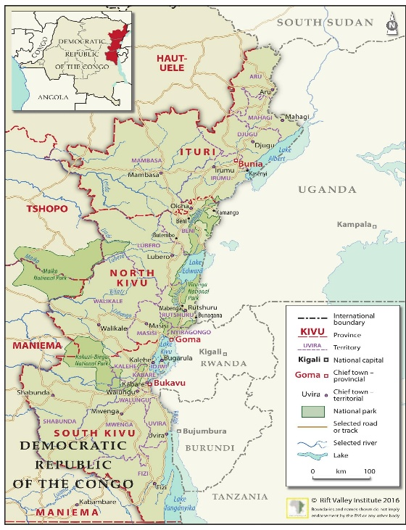
The Ituri Province is the center this Ebola epidemic.
Nyankunde Hospital is located in Ituri Province
Nundu Deaconess Hospital is in South Kivu.
Champions for Congo is staying in close communication with our partners on the ground. Nundu Deaconess Hospital and health centers are prepared to respond to urgent community needs. The Free Methodist Church DRC and our medical personnel remain safe in North and South Kivu. However, we are concerned that one case has been reported in Goma and one case near Bukavu. This Ebola outbreak adds another layer of urgency to an already fragile humanitarian reality in eastern Congo. Communities around Goma and Bukavu continue to face instability, displacement, and limited external support, placing increased pressure on stressed local organizations.
Please pray for those who are sick, comfort for grieving families, protection for healthcare workers, and wisdom for local officials and frontline responders. Yes, pray for Eastern Congo and the challenges the people are facing. A million displaced people are especially vulnerable. Food insecurity is becoming more of an issue. A compromised supply chain, withdrawal of USAID funding, and breakdown of civil authority have made containment of this virus even more difficult.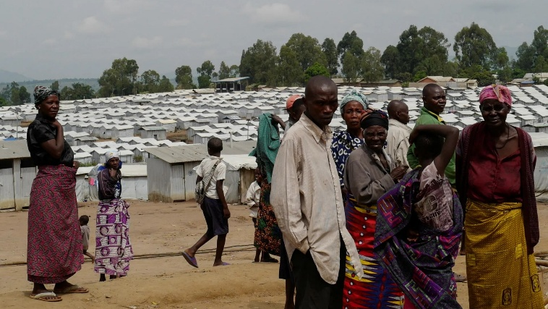
We are positioned to respond through trusted community relationships, public health education, prevention efforts, and local mobilization. In the face of civil conflict and this deadly epidemic, we welcome your financial support more than ever. Gifts to Champions for Congo help healthcare workers to respond quickly, bringing routine and urgent healthcare, prevention resources, and hope to vulnerable communities facing crisis.

All contributions to support healthcare ministries in the DRC are received by the Butterfield Foundation. To give, you can go to our website: www.congohealth.org or mail checks to Butterfield Foundation, 8308 N May, Suite 200, Oklahoma City, OK 73120. You may also use this QR Code. Thank you for your generosity. Tim Kratzer

