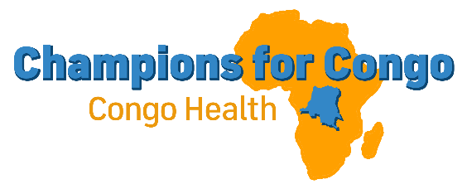
NUNDU NEWS JANUARY 14, 2026
AN UNCERTAIN FUTURE
The New Year began as it began almost a year ago, in war. We do not know how this conflict will end. There was fear that the M23 would advance south to Nundu, but then they staged a strategic withdrawal from Uvira. From strategic positions in the foothills, they have attacked villages which are on the road south to Nundu.
Nundu Deaconess Hospital continues to provide much needed medical care. Reports from Nundu indicate that the hospital staff remain calm, with most of the staff back on duty. Many of the staff had gone into hiding, fearing the advance of the invading forces. Now the village of Nundu is calm, but war casualties from villages up north are being taken to the hospital. To date, 95 wounded FARDC and Wazalendo have been admitted. There has been a cholera outbreak among the military at a military base a few miles north of Nundu with 47 cases admitted. Hospital supplies of medications and IV fluids have been depleted. The military pharmacy in Kalemie has replaced the IV fluids used, but this pharmacy is not thought to be a source for pharmaceuticals and medical supplies.
Resupplying the hospital is an urgent priority. Pharmaceuticals, imported from Burundi by unofficial channels, can be found in Baraka but at a high price. To import medications and supplies, cost of transportation and “process fees” have been significant. A limited number of boats are crossing over from Burundi to the DRC. Corn meal flour and other food items are being transported. There is also local production of food, but in limited quantities. Currently there is no way to travel between Nundu and Uvira, which is our center for commerce.
The hospital team needs financial assistance. We have been able to transfer financial assistance to our hospital staff by Mobile Money. With an ap that individuals have on their phones, we can transfer small sums of money at a time. However, many times the exchange rate is not favorable because of the limited availability of cash.
GENEROSITY
In the last quarter of 2025 we have finished the year strong. Thank you for your generosity which has given us a cash reserve which we will deploy as we find a way to address this humanitarian crisis of extreme proportions. In the face of this uncertainty, we have hope. We have a mission of delivering compassionate healthcare, empowering communities, and building a sustainable healthcare system. The mission of Nundu Deaconess Hospital is to shine light in the darkness.
THE BUTTERFIELD FOUNDATION
We’re Excited to Announce a New Partnership!
Champions for Congo is now a project of Butterfield Foundation, a 501(c)(3) nonprofit organization! This partnership is rooted in shared faith, alignment of mission, and a desire to see God’s work flourish through our collaboration. This relationship will allow Champions for Congo to focus more fully on its mission while benefitting from administrative and governance support. For the present, contributions you wish to make will be processed through our CFC GuideStream account at www.congohealth.org. We continue to be affiliated with CAHO.
UNITY IN CHRIST
Conflicts in society and even in the church are not new. Paul planted the church in Ephesus and discipled many believers there. Some were Jews and others were Gentiles. The Jewish diaspora was under the control of the Roman Empire. There was political tension and a sense on the part of the Jews that they should be remain separate from their Gentile ruling class. But as the Gospel was shared, people from all walks of life came together.
For Christ himself has brought peace to us. He united Jews and Gentiles into one people when, in his one body on the cross, he broke down the wall of hostility that separated us. He did this by ending the system of law with its commandments and regulations. He made peace between Jews and Gentiles by creating in himself one new people from the two groups. Together as one body, Christ reconciled both groups to God by means of his death on the cross, and our hostility toward each other was put to death. Ephesians 2:14-16 NLT
We pray that this unity will prevail in the DRC, bringing under the power of the Cross this conflict. Too many lives have been lost and so many people have been displaced.
Thank you for your financial support and prayers, needed more than ever. We will deliver, empower, and build; and if necessary, rebuild after this conflict is over. This mission sounds like the call to rebuild after the Babylonian captivity and to shine a light in the darkness.
Thank you for being a Champion for Congo.
Shalom, Tim Kratzer

