NUNDU NEWS December 12, 2025
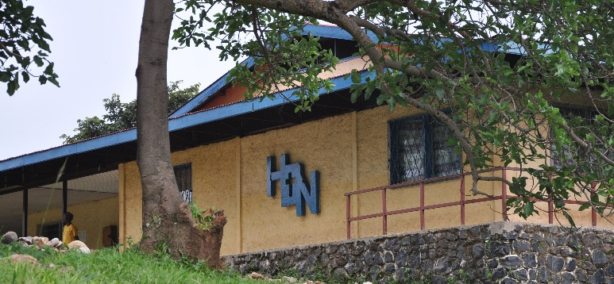
You may have seen in the news that Paul Kagame, Donald Trump and Felix Tshisekedi met in Washington DC one week ago, December 4, for the signing ceremony of a peace deal between Rwanda and DR Congo. Unfortunately, this peace agreement has not born fruit as shortly after this ceremony new hostilities broke out north of Uvira between the M23 and the armed forces defending DR Congo. Though there are conflicting reports on who is responsible, the reality is that the M23 moved south to take control of the city of Uvira Tuesday, December 9.
Uvira is a city of 700,000 with an estimated 200,000 inhabitants fleeing in the face of open gun fire and bombings. The Congolese soldiers defending the city have abandoned their posts. The border between DR Congo and Burundi, 12 miles east of Uvira, is closed. Many of those who were able to get across into Burundi before the closing of the border are in detention camps. The streets of Uvira are quiet now, but this is not a peaceful calm. Fear prevails and there is little moving about as many citizens have lost their lives in the crossfire of battle.
This city is a strategic commercial and political center. Here Nundu Deaconess Hospital purchases pharmaceuticals, medical supplies, fuel, maintenance supplies, and building materials. This is an important transportation hub. To get to Burundi from Nundu you must pass through Uvira. The government offices from the provincial capital of Bukavu had relocated here after that city came under M23 control. It also has strategic military importance, as there is a military base here as well as a port on the northern shore of Lake Tanganika.
Nundu, 40 miles south of Uvira, is quiet but the community and hospital staff are living in fear, not knowing what is going to happen. During the past four days there has been a steady stream of government soldiers, their families, and local citizens moving south along the N5 corridor, the main road which passes by Nundu Deaconess Hospital. The hospital remains open, but with fewer than half of the hospital team.
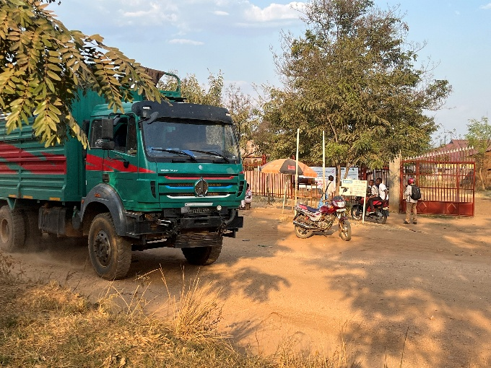 N5 passing by the entrance to Nundu Deaconess Hospital is now a column of people marching south.

Here is a personal account from a Nundu doctor in training in a neighboring country:
I want to share with you what is happening in my country. My heart is deeply wounded, and I am constantly worried about the future of the hospital at Nundu. So many families have been forced to abandon their homes and are now hiding in the forest, living in fear and uncertainty. One of my sisters from Nundu told me that she is now with her seven children in a forest near Kenya Primary School (a village near the lake not far from Nundu.)
We also received heartbreaking news that a boat, heavily loaded with people fleeing the violence, capsized (on Lake Tanganika). Many who were simply seeking safety lost their lives in this tragic moment.
Please keep us in your prayers and pray for peace in our country. We are living through a very difficult time, and we need strength, compassion, and hope to carry us through.
Praise the Lord! He will provide and protect. Basic medical services are being provided. Your generosity and prayers have been foundational to this ministry of compassion.
Yes, thank you for your prayers and ongoing financial support as we face an uncertain future. You can give to the Nundu School of Nursing and Nundu Deaconess Hospital projects through our website www.congohealth.org. I will provide an update soon and report on our Nundu School of Nursing building project.
Tim Kratzer, Chair of the Congo Action Group, Champions for Congo

