NUNDU NEWS October 21, 2025
Nundu School of Nursing Midwife Building Project Update
Construction of three midwife classrooms and offices is moving ahead with phase one nearing completion. The war, which resulted in the fall of Goma in January and then Bukavu in February, put on hold plans to build. Now, with relative calm and ability to circulate in our immediate area, the team has resumed this vitally important building project. This project, made possible by partnership with the Butterfield Foundation, aims to construct a modern and well-equipped midwifery training facility for the Nundu School of nursing.
Site Preparation: Site preparation of phase one has been completed. Earthwork was initially planned with a chain loader (excavator), but mechanical breakdown required manual excavation. Manual labor allowed the project to continue and provided jobs to local community members although it was time consuming which affected the construction schedule.
Brick production started immediately after site preparation. Of the bricks required for the next phase of construction, 60% have been produced using soil, sand and cement. Production of bricks is ongoing and expected to be finished before wall elevation begins.
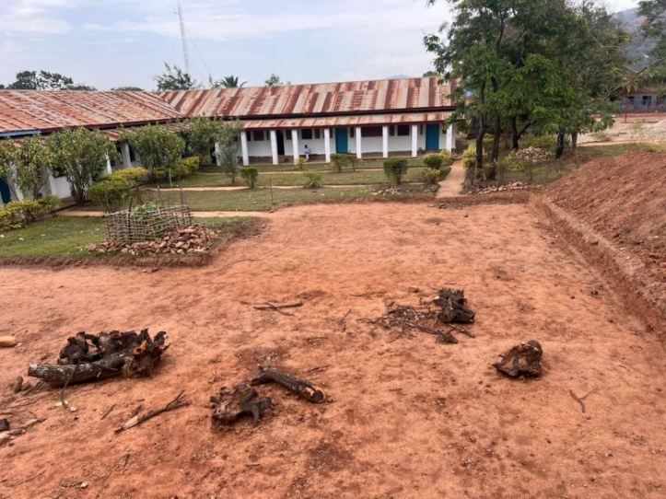
Site clearing and preparation: • Manual labor minimized fuel use and carbon emissions. • Cleared vegetation will be replaced with trees for landscaping post-construction.
Foundation Phase: The project will now be transitioning into the foundation phase. Preparations for layout of the foundation, material mobilization, and site organization are in progress. Despite earlier delays caused by equipment failure and following recovery through manual labor, the project is back on schedule which will allow completion by February 2026. However, unstable weather patterns may impact construction going forward.
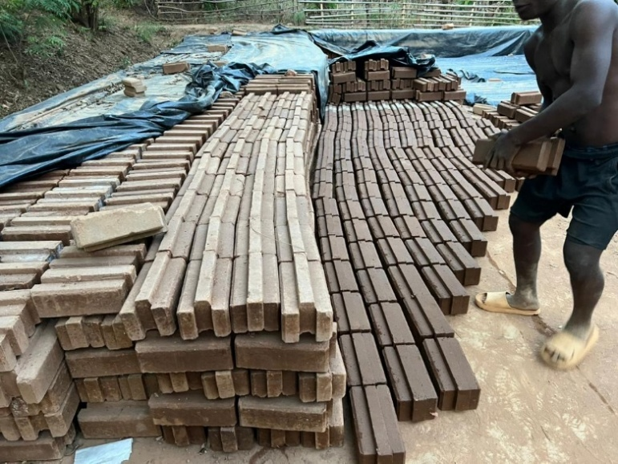
A worker making bricks - Clay resourced on site is used for brick production, reducing the environmental footprint.
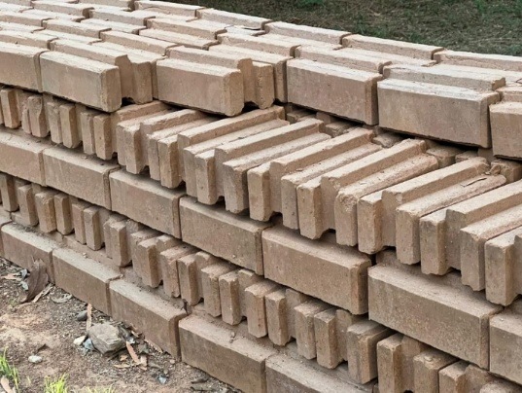
Bricks are drying and stacked on site, ready for the next phase of construction.

Key Achievements:
✅ Successful site preparation despite equipment failure
✅ 60% brick production milestone achieved
✅ Community participation strengthened through employment
✅ Environmental footprint minimized via sustainable practices
Next Steps:
- Commence foundation excavation and pouring concrete footings.
- Complete remaining brick production to 100%.
- Mobilize rebar, cement, formwork, aggregates, and tools.
- Maintain weekly supervision meetings and reports.
Summary: The Nundu School of Nursing midwife building project is progressing steadily. The early mechanical challenges affected the construction schedule, but they were effectively mitigated through community engagement in manual work, ensuring continuous progress and social benefits. With the foundation phase about to begin, the project remains on track to achieve its objectives, with completion projected for February 2026.
Report and photos by Paul Ikocha, builder
SCHOLARSHIP RECIPIENTS
Dr. Luc, Ob/Gyn instructor, meets with midwife students who are scholarship recipients.
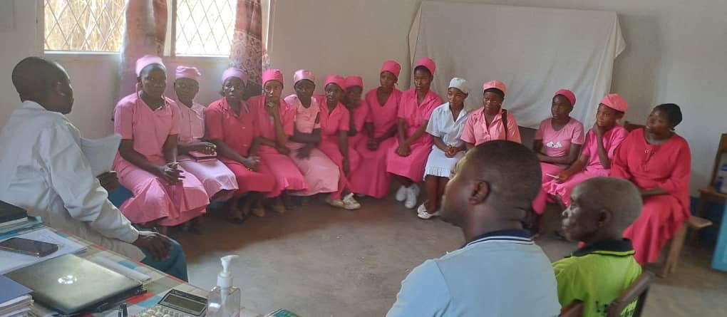
The parents of these midwife students send their thanks. Having limited financial resources, they were especially appreciative when they learned that their daughters were receiving scholarship support.
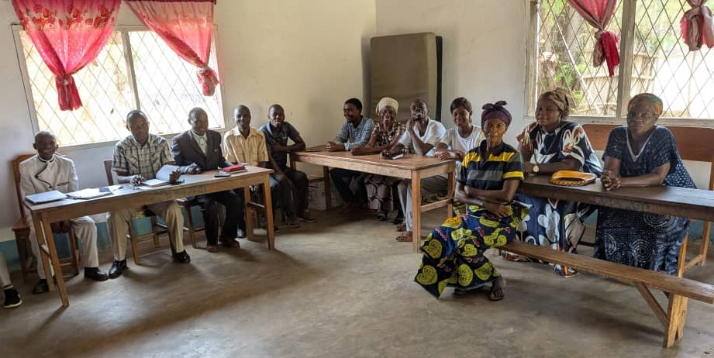
Dr. Luc is meeting with 3rd and 4th year midwife students. Having been trained as an obstetrician, he is focusing on improving the academic training and clinical experience of our students.
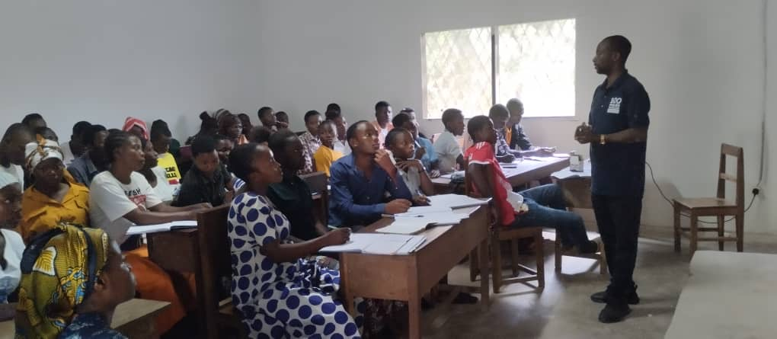
Dr. Marx Connects with Arizona Partners
As part of a September/October visit to the US, Dr. Marx presented the mission and vision of Nundu Deaconess Hospital to my home church here in Southern Arizona. We champion equitable, holistic healthcare in rural Eastern Congo by:
- Delivering compassionate, trauma-informed treatment and healing.
- Empowering communities to take charge of their health and economic futures.
- Building a resilient and sustainable healthcare system for generations to come
Our vision: Healthy, thriving, and resilient communities in Eastern Congo where every life is cherished and uplifted. Our church here GIVES, PRAYS, and STANDS with DR Congo. Together, we are saving lives and shaping a healthier future!
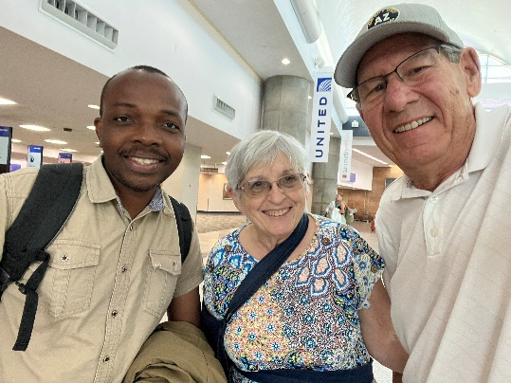
Tim and Connie Kratzer connecting with Dr. Marx and celebrating his visit to Arizona

PLEASE CONTINUE TO PRAY FOR:
- The Nundu School of Nursing students
- The ability to purchase building materials so that the building project can continue
- The provision of medications and essential supplies for Nundu Deaconess Hospital
- Our hospital staff as they continue to provide compassionate healthcare
- That revival will move through this region of conflict which will result in racial and political reconciliation
- That our Heavenly Father will soften the hearts of those who have found themselves continuing this war
Thank you for your prayers and ongoing financial support as we face an uncertain future. Your generous support of the Nundu School of Nursing scholarship fund is making a difference!
You can give to the Nundu School of Nursing and Nundu Deaconess Hospital projects through our website www.congohealth.org.
Tim Kratzer, Chair of the Congo Action Group, Champions for Congo

