NUNDU NEWS July 2025
The Impact of USAID Funding Cuts on the Health System at Nundu Deaconess Hospital in Eastern DRC
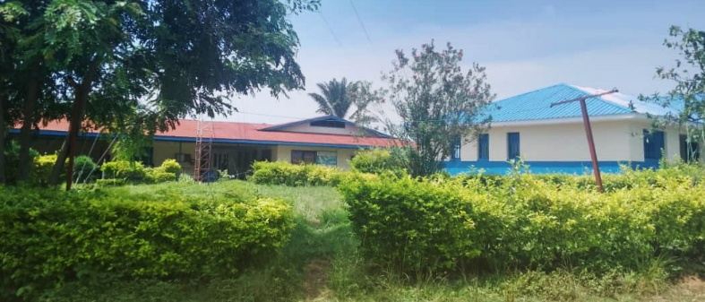
Nundu Deaconess Hospital

Introduction
For decades, the United States Agency for International Development (USAID) has been a cornerstone of health sector development in the Democratic Republic of Congo (DRC). Through initiatives targeting malaria, tuberculosis, maternal health, and health system strengthening, USAID has helped millions access life-saving care. However, recent funding suspensions have triggered a cascade of disruptions, particularly in the eastern provinces, where fragile health systems are now buckling under the weight of civil unrest and resource scarcity.
USAID’s Historical Role in DRC’s Health Sector
USAID has invested billions in the DRC since the early 2000s, with over $935 million disbursed in 2023 alone. Key programs include:
- Integrated Health Program (IHP): Operating in 9 provinces and 179 health zones, IHP has improved access to quality care for over 47 million people. It supports maternal and child health, nutrition, immunization, and disease prevention.
- End Malaria Project: In 2023, USAID provided $15.88 million to distribute insecticide-treated bed nets to over 28 million people¹.
- Nutrition and Child Health: Between 2021 and 2022, USAID reached 26.7 million children with nutrition programming and vaccinations³.
- Emergency Response: USAID has been instrumental in responding to outbreaks of Ebola, mpox, and cholera, and in providing humanitarian aid during displacement crises.
These programs have not only saved lives but also built local capacity, improved data systems, and fostered community engagement through initiatives like Champion Communities and health development committees (CODESAs).
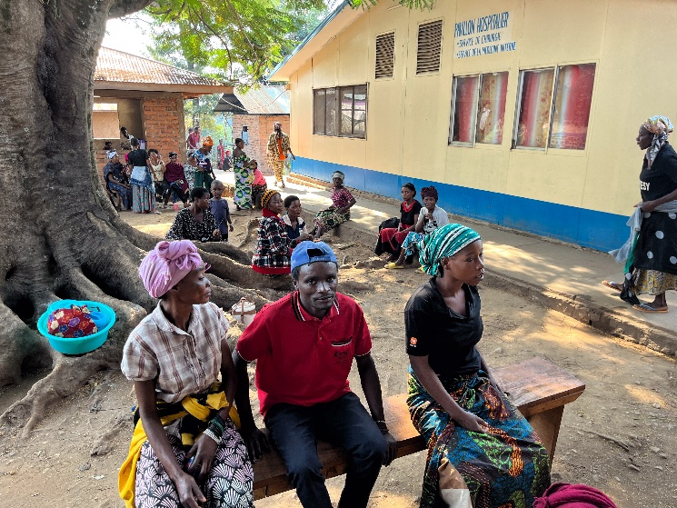Patients and family members at Nundu Deaconess Hospital
Consequences of Funding Cuts in Nundu Health Zone
The USAID funds cuts affect differently various stakeholders in Africa, and the Democratic Republic of Congo, especially the eastern part that is facing political instability. It is a moment when humanitarian aid is needed more than ever before because the suffering is at its peak, when the cuts of USAID funds act like lightning causing a double burden to the people.
The impact goes beyond a single person suffering, affecting even organizations that were implementing projects with funding from the USAID, the case of the International Medical Corps (IMC) in the Nundu Health Zone in South Kivu. This disengagement of IMC from Nundu, has had immediate and far-reaching effects in the areas of their interventions including and not limited to the Reduced Community Outreach: Preventive health education, especially around family planning, has sharply declined. The Nundu health zone and hospital are struggling to manage patients in this fragile context when the pharmacy is empty for drugs that came from program supported initially by the USAID. The main consequence on the ground is now:
- Shortage of Essential Medicines: Supplies of antimalarials, anti-tuberculosis drugs, and lab reagents for TB are frequently unavailable, delaying treatment and increasing disease burden.
- Provider Capacity Erosion: Without technical and financial support, health workers lack training, supervision, and motivation.
- Rising Mortality Rates: Infant deaths, low birthweight deliveries, and maternal fatalities are on the rise.
At Nundu General Hospital, the situation is especially dire. Patients diagnosed with tuberculosis are placed on waiting lists for over a month due to drug shortages, increasing both mortality and community transmission.
The lack of antimalarial drugs is even more concerning, as malaria remains the leading cause of morbidity and mortality in the region. Shortage of malaria drugs is a serious concern requiring particular attention.
Civil Unrest and Humanitarian Crisis in South Kivu
The health crisis is compounded by escalating violence in South Kivu. Armed clashes have displaced over 850,000 people, half of them children. Hospitals are overwhelmed, health workers are fleeing, and access to clean water and sanitation is severely limited. In this volatile context, the absence of USAID-supported health interventions is not just a setback—it’s a humanitarian emergency.
Perspective on the ground
The USAID funds cuts information was perceived differently on the ground; some analysts think it is a good thing for African leaders to learn how to use their own responsibility to better serve their people and not rely on external aid. Of course, some countries are well positioned to start thinking their way forward after the USAID funding cuts. Unfortunately, this is an overwhelming situation to manage for countries like the Democratic Republic of Congo struggling to end war and conflict, and now called to fill the gap of USAID, which is unrealistic goal unless new alternatives funding option emerges.
Conclusion:
The people of Nundu and surrounding areas are facing a perfect storm of disease, displacement, and dwindling resources. The shortage of antimalarial drugs at Nundu General Hospital demands urgent support to keep serving effectively the community which relies for it for appropriate care, especially as civil unrest continues to destabilize South Kivu.
In the face of adversity, the resilience of Congolese communities endures. But resilience alone cannot fill empty shelves or treat malaria without medicine. The time to act is now.
Dr. Marx Lwabanya, Nundu Deaconess Hospital
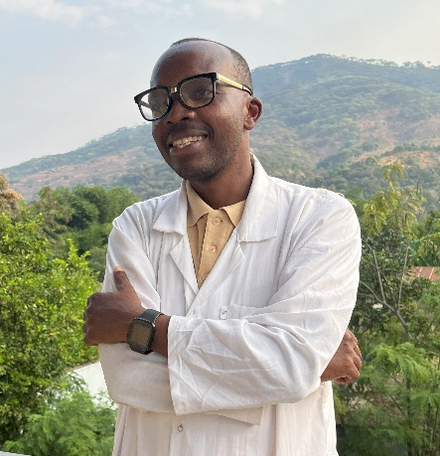

Partners in Ministry
Champions for Congo builds capacity and serves as a link with our team in DR Congo. Given the current Congo crisis, your support is valued more than ever.

Thank you for being a partner in ministry. As you pray and support projects with your gifts you are an essential part of our team. Even as civil conflict continues in South Kivu and USAID funds have been withdrawn, caring for those in need goes on. Pray with us that the peace accord signed June 27 will bring about enduring peace.
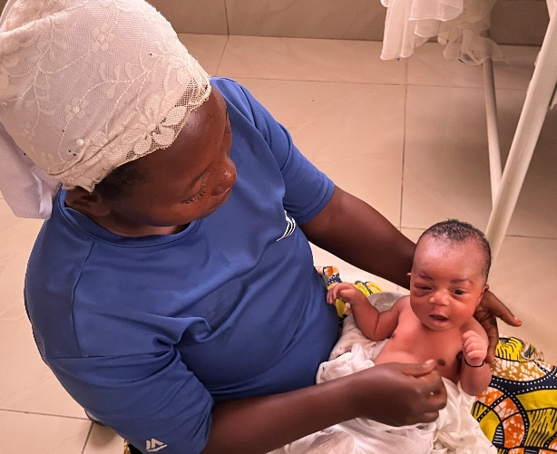
Mother with newborn Nundu Deaconess Hospital maternity
Blessings and thank you for your support,
Dr Kratzer www.congohealth.org

USAID in the Democratic Republic of the Congo - The Borgen Project
USAID Integrated Health Program, DRC - i+solutions
Abt Leads USAID’s Integrated Health Program in the DRC | Abt Global
Integrated Health Project in Democratic Republic of Congo: A Case Study on Citizen Engagement and its Influence on Health Program Outcomes
Tens of thousands of families displaced by fighting in DR Congo’s South Kivu as UNICEF scales up humanitarian response
Dire health and humanitarian crisis in eastern Democratic Republic of the Congo prompts escalation of efforts by WHO, partners

