NUNDU NEWS June 2025
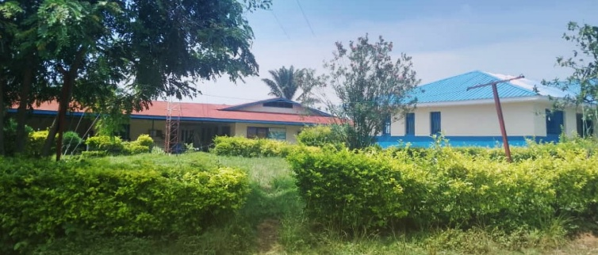
DEACONESS NUNDU HOSPITAL REIMAGINED
Deaconess Nundu Hospital is a faith-based organization founded in 1984 through a partnership between local communities in Eastern Congo and Free Methodist World Missions. Our goal is improving the health, resilience, and dignity of underserved populations in rural Eastern Congo. Based in Nundu, a region that has long been affected by violent conflict, poverty, and high mortality rates from preventable causes, the organization serves a catchment area of over 300,000 and extends its reach throughout rural South Kivu province.
What we see throughout South Kivu mirrors what took place in the early church. The church described in Acts 6 was rapidly growing, so much so that there was a group of believers whose needs were being neglected. Widows would come to Jerusalem, as was their custom, to receive assistance. The Greek-speaking Jewish widows claimed that they were not receiving their share of assistance, as Aramaic-speaking Jewish widows were receiving more than their fair share.
The observation was made that apostles should spend their time teaching the Word of God, not running a food program. Think of this as a social service program. serving the widows in need. What was the response to this need? Seven men were chosen, including Stephen, a man full of faith and the Holy Spirit. These men are considered the first deacons in the church, derived from the Greek diakonein, to serve.
Healthcare ministries of the Free Methodist Church DRC are also engaged in responding to human need. Deaconess Nundu Hospital is serving the population in a holistic way. We go beyond treating illness to restoring hope so that our population can move beyond the cycle of poverty and violence. Deaconess Nundu strives to transform lives, fostering resilience and offering a pathway to a brighter, healthier future. In Swahili there is a phrase, Jali Afya, Care for Health, which embodies our vision and mission.
OUR VISION
A world where everyone has access to holistic healthcare and the opportunity to live a healthy, empowered life with dignity and hope.
OUR MISSION
We champion equitable healthcare in rural Eastern Congo by uplifting and empowering communities and restoring hope for underserved communities.

OUR TEAM
Doctors, Nurses, Educators, Administrators, Technicians, Maintenance staff - All commissioned to serve. Dr Demoule is the newly appointed medical director of Deaconess Nundu Hospital. Dr Marx continues as assistant to the medical director as well as providing leadership in reimagining the mission of healthcare ministries in South Kivu.
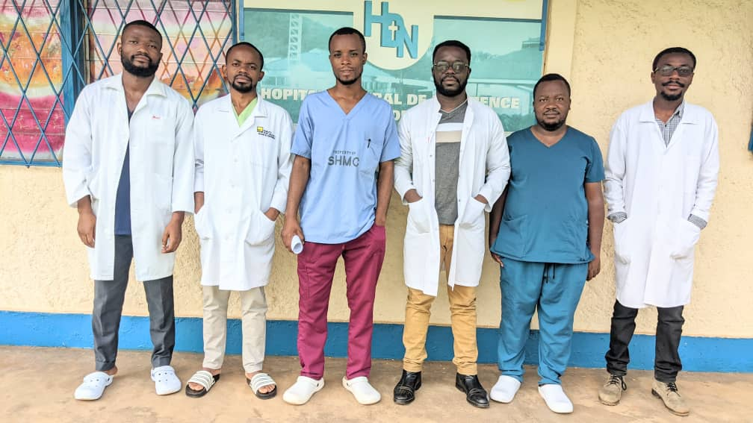

OUR PROGRAMS
Deaconess Nandu Hospital - A 110-bed hospital with 78 staff and 5 physicians, offering comprehensive health care, including emergency services, maternal and child health, general surgery, and treatment for malnutrition, diabetes, and hypertension.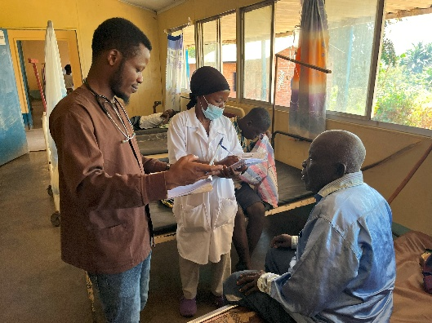
Rounding with Dr Sodi and nurse Jessica

Community Health Worker Program - Over 100 CHWs deliver essential health services, including family planning, antenatal care, and nutrition education. CHWs are vital links to healthcare, connecting patients to 21 rural health centers and reaching remote and underserved communities.
Maternal Child Health - We strengthen primary healthcare and empower local providers to reduce maternal and infant mortality. Through training and life-saving equipment, we address the three delays—seeking, reaching, and receiving care—to ensure timely support for mothers and children.
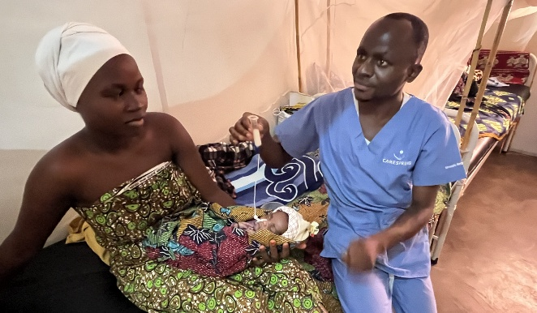 Neonatal intensive care unit

Education and Training - At the NDH School of Nursing, we’ve graduated over 450 nurses, many serving across the region. Our new midwifery program addresses a shortage of skilled midwives, helping reduce maternal mortality. We foster a culture of clinical research to improve care and contribute to better health outcomes in the region.
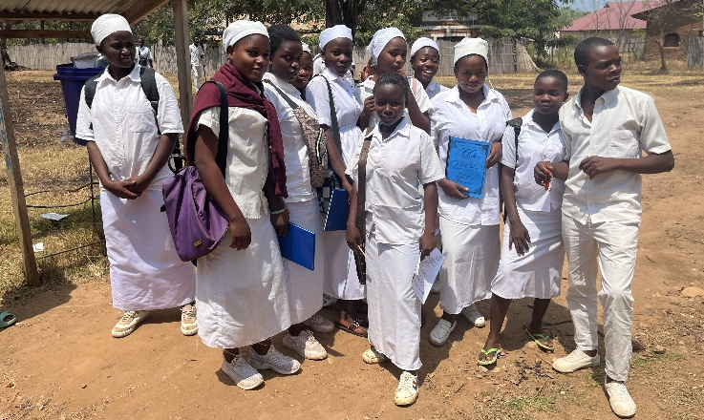 Nundu School of Nursing students

Nutrition and Economic Empowerment - Our holistic program addresses malnutrition by providing meals in the hospital and teaching families to grow healthy crops. We also offer start-up capital for income generating activities, promoting economic empowerment and self-sufficiency.
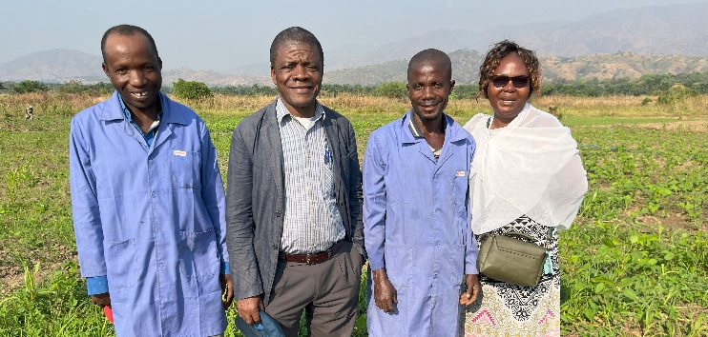 ICCM sponsored agriculture project

IMPACT AND OUTCOMES
Through our comprehensive and integrated approach, Deaconess Nundu is making significant strides in improving health outcomes and building resilience in the region.
Key outcomes include:
- Reduction in maternal and neonatal mortality through better access to skilled birth attendants and emergency obstetric care.
- Improved nutrition and child health outcomes, with thousands of children receiving life-saving nutrition and health education.
- Increased access to mental health care, especially for survivors of sexual violence and trauma.
- Expanded healthcare access for remote underserved communities through a network of CHWs. Capacity-building efforts leading to the training of hundreds of nurses and midwives annually, contributing to the region’s growing healthcare workforce.

PARTNERS IN MINISTRY
CHAMPIONS FOR CONGO builds capacity and serves as a link to partners in North America. The CONGO ACTION GROUP is the advisory group connecting Champions to the Central Africa Healthcare Organization.
- Tim Kratzer, MD Retired Missionary Physician
- Norman Wetterau, MD Retired Primary Practice
- Glenn Snyder, MD, MPH, President CAHO
- Kenneth Kratzer, Wealth Management Consultant
- Randy Matthewson, Retired engineer, missionary volunteer
Thank you for being a partner in ministry. As you pray and support projects with your gifts you are an essential part of our team. Even as civil conflict continues in South Kivu, caring for those in need goes on. We are looking for ways to keep our partners informed. Would you be interested in quarterly updates via zoom, which will be possible if we are able to establish better internet service? Thank you for being a partner in ministry.
Thank you for your support,
Dr Kratzer and Dr Marx www.congohealth.org

