**Nundu News November 27, 2024**

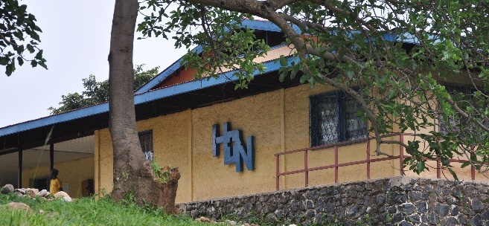

**CELEBRATING THE LORD’S PROVISION**

**Thanks to your generous support,** Champions for Congo (CFC) has partnered with Nundu Deaconess Hospital and the Medical Coordination Office of the Free Methodist Church of the Democratic Republic of Congo (FMC-DRC) in providing holistic, compassionate healthcare in South Kivu, transforming the lives of families and communities throughout South Kivu.

CFC isan action group of the Central Africa Healthcare Organization, a 501c3 non-for-profit whose mission is to support, promote, and facilitate Christian health care through partnership with hospitals and clinics affiliated with the global Free Methodist Church.

**In the year to date you have given $104,886.** Projects which you have supported this year include salary support, station and hospital, maintenance, pharmacy, patient care, nutritional support, and school of nursing subsidies.

**As we reach the end of 2024, we need to raise about $18,000 to meet our usual commitments**. **Would you consider a year-end gift to assist with those accounts we find are in deficit?**  We are thankful for your faithful support and prayers.

Funds in Deficit include the following:

* Doctor Salaries              $1100
* Staff salaries                $3870
* Nutritional support     $5600
* Hadduck House $2615
* Maintenance                  $4571
* Pharmacy $1707

In addition, we have been supporting scholarships for two doctors and two support staff with a current deficit of $9924. Receipts in 2024 to date are $10,230 with disbursements of $20,745. A generous gift from the Free Methodist Healthcare Fellowship is providing support of Dr. Baron’s OB/GYN residency in Bujumbura as previously reported and a private donor is supporting a radiology student.

**Butterfield Grant Approved   
NEWS FLASH!! The Butterfield Foundation board of directors … have approved a grant to CAHO in the amount of $64,000 to help fund the construction of the midwife classroom. building at ITM Nundu as proposed.**

**The Nundu School of Nursing midwife expansion, 2025.**

**Impact of Trained Midwives**

The number of qualified midwives is insufficient. There are trained birth attendants in only 35% of the 21 health centers in the Nundu Heath Zone. Midwives are assigned where the need is the greatest, with a goal of two birth attendants per primary care facility and more per secondary care facilities. Health centers in neighboring health zones of South Kivu report the same need. With the training of midwives, the need for qualified midwives will be addressed over the next five years as we hope to see 67 midwife graduates. Assisted deliveries monitored by skilled birth attendants will increase, with a corresponding decrease in maternal-child morbidity and mortality.

**Summary - Impact**

Construction of the Midwife Classroom Building will enable ITM Nundu to provide the learning environment for nurses and midwives who will provide holistic care which is transforming. Adding four classrooms and two offices will allow space dedicated to the midwife track.

**Improved Outcomes**

To improve academic achievement and professional performance, we are launching a scholarship program which will assist qualified students in need of financial assistance. Scholarships of $360/year will support a student for one year. In addition, $3600 will support a university-trained nurse midwife instructor. **Would you consider adopting a student or students?**  You will receive a photo and a biography of the students you support.

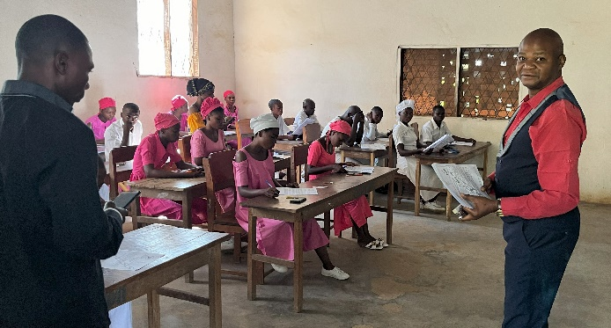 Nurse midwife students taking final exams.

**New Investments in Hospital Infrastructure.**

In the course of 2024, we have experienced many unexpected blessings. *Medicin du Monde* has contributed funds that have allowed the hospital to make improvements to its infrastructure. One major improvement was the refurbishment of the hospital laboratory.

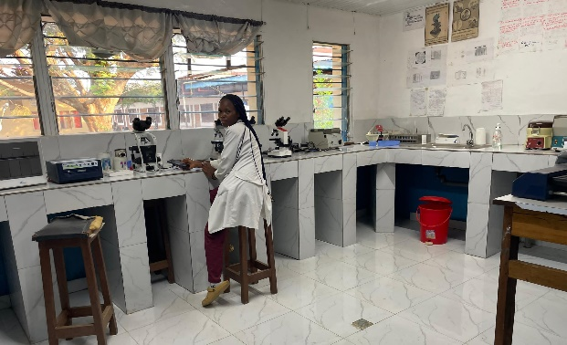

The World Bank funded construction of a new pediatric pavilion which will provide for an improved NICU, establish dedicated pediatric intensive care, and improved pediatric wards. The present pediatric pavilion will be repurposed as the surgery pavilion.

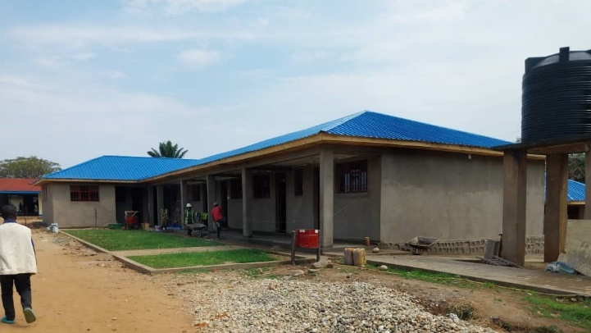The new pediatric pavilion.

**Two Doctors Join Hospital Staff**

We are blessed to have two doctors who joined the medical staff in 2024.

Dr Joas ISUMBELO NGUMOYA, MD.

Dr Joas ISUMBELO NGUMOYA, has joined the NDH team officially this October 2024. Dr Joas is not new as he come to Nundu a year ago for an internship at the Nundu Deaconess Hospital. After six months of internship the hospital requested him to stay on at Nundu to cover for doctors who were called away for surgical training.

Dr. Joas is interested in general surgery as well as internal medicine and can manage very well most of the common obstetrical emergencies. He is a graduate of *Universite Officielle de Bukavu* with a Bachelor of Medicine.

Dr. Remus WELONGO SONGOLO , MD.

Dr Songolo has re-joined Nundu Deaconess Hospital in October 2024 as a general physician.

Dr. Songolo served at NDH from 2012 to 2016, a period during which he received training in eye care from Dr Cropsy, an ophthalmologist at Kibuye Hope Hospital in Burundi.

Dr Songolo then served in the North Kivu province from 2017 to 2019, now a center of ongoing conflict.

Dr Songolo returned to South Kivu, to serve as the medical director at the Mikenge Hospital, a position he held for one year. He was then assigned to healthcare facilities near Nundu, Lweba referral health center and Mshimbakye hospital.

With his assignment to NDH, the hospital is envisioning a major upgrade of the eye care department. He graduated from *Universite Evangelique en Afrique* in 2011 with a Bachelor of Medicine.

The leadership team is planning for the future of healthcare at Nundu Deaconess Hospital and its allied healthcare ministries. Stay tuned for more news and opportunities to become involved.

For the present, we invite you to join us in a prayer of thanksgiving for all that the Lord is doing at Nundu. **Would you consider a year-end gift to assist with those accounts we find are in deficit?**  **Or perhaps you would want to support a student or students in 2025?**

**Thank you for your financial support and prayers. You can make contributions by mailing checks to CAHO, PO Box 580, Spring Arbor, MI 49283.** You can also give online at [**www.congohealth.org**](http://www.congohealth.org) or [**www.gocaho.org**](http://www.gocaho.org). Indicate the project you would like to support.

Tim Kratzer November 2024

Chair of the Congo Action Group representing Champions for Congo on the CAHO Board.