**CELEBRATING THE LORD’S PROVISION**

**Thanks to your generous support, we have been able to finish the year strong.** Champions for Congo partners with Nundu Deaconess Hospital in the Democratic Republic of Congo in providing holistic, compassionate healthcare in South Kivu, transforming the lives of families and communities in South Kivu, a province in eastern DR Congo.

Projects which we have supported this year include station and hospital salary support, pharmacy, patient care, nutritional support, and school of nursing subsidies.

**Staff Salary Support**

Healthcare providers at Nundu Deaconess Hospital are tirelessly providing patient care with limited incomes. Many staff members struggle to make ends meet from month to month. Staff salary support is greatly appreciated.

**Pharmacy Support**

NDH has signed an MOU to integrate with a government program funded by the World Bank, intended to improve patient outcomes while at the same time making patient care more accessible.

However, the results are mixed. Utilization of a flat rate to bill for services limits what can be charge for medications. As a result, the number of patients has increased with a corresponding increase in the medications and other supplies needed. The World Bank program covers the bill after assessment of quality of care on each chart. Payment should be received for each quarter but is often delayed.

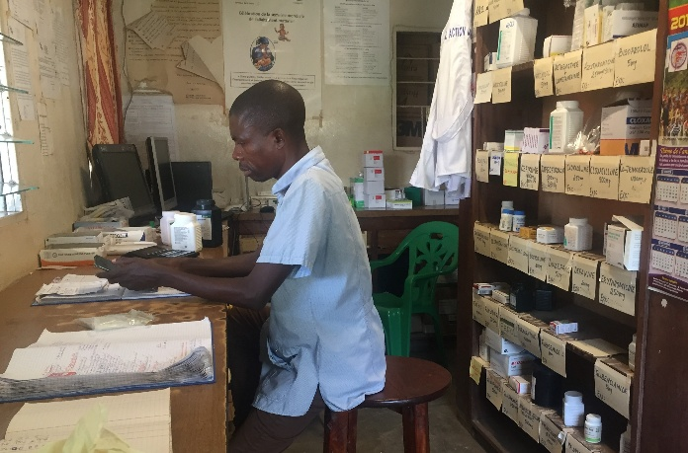

**Patient Care**

The World Bank program, by imposing a reduction of what healthcare facilities can charge, has negatively impacted the hospital budget. What can be charged for patient care is capped, but even this reduced amount of $22-29 for pediatric patients, for example, is more than what most families can afford.

In 2024 more than 400 vulnerable children received care free of charge through the patient care fund. Many of these children are malnourished, have a chronic condition like sickle cell anemia, are from internally displaced families, or supported by a single mother without any reliable source of income.

Many of these children would have either died or their families would have been forced into poverty by selling their land or livestock to cover the medical bill. What you give makes a difference. An average of $25 covers the cost of an infant’s hospitalization; $250 covers the bill of ten children, $2500 covers the bill of 100 children.

**Nutritional Support for at-Risk Patients**

Nundu Deaconess Hospital is the referral hospital for 21 rural clinics. Patients receive meals from home whenever relatives visit, but it is difficult for most families to visit their loved ones twice a day. Many patients rarely get breakfast. Because of the generous donations from CAHO, the hospital continues to serve an average of 152 cups of porridge every morning with “Handazi” (a slice of bread).

Patients with malnutrition receive additional food supplements.

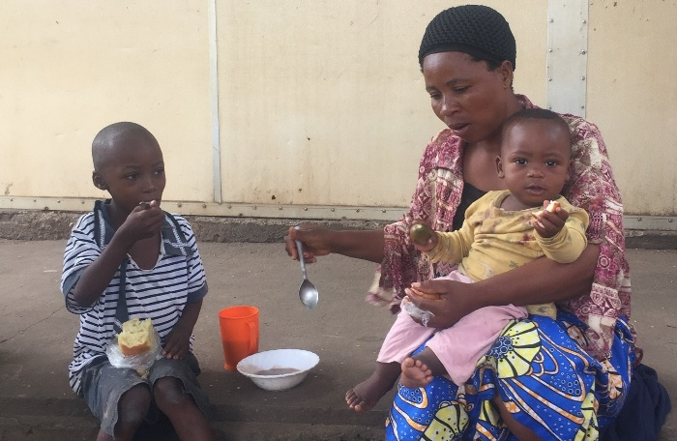

We are thankful for your prayers and continued support. www.congohealth.org Tim Kratzer