**NUNDU NEWS February 23, 2025**

Dr. Mike McGee, ENT surgeon from Oklahoma City, is a longtime friend of Nundu Deaconess Hospital and mentor of Dr. ByaMungu. He traveled to Nundu in January to encourage Dr. ByaMungu and assist primarily with head and neck surgeries. With more than 120 beds, NDH serves many people from different places beyond Nundu Village. Located in DRC in the South Kivu province, Fizi territory, this hospital is considered a light for the people in this area. Its impact on society is great and gives relief and hope to this underserved population.

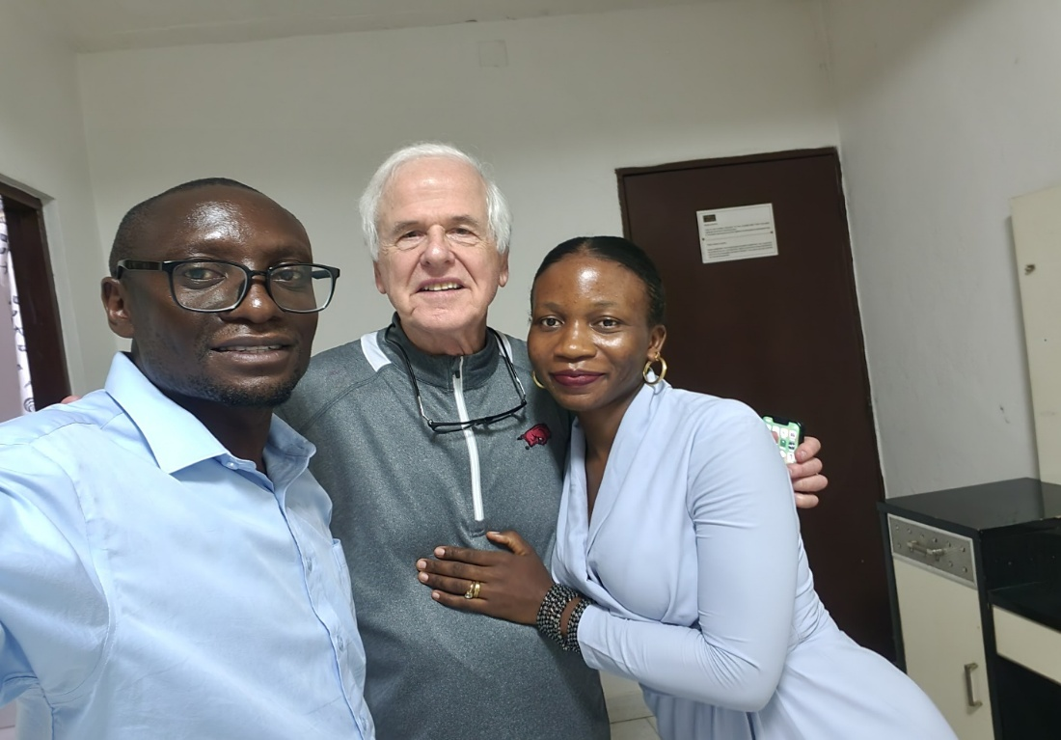 **Arrival in Bujumbura, Dr. McGee with Dr. ByaMungu and his wife Francine**

**Work at Nundu**

Dr. McGee was a blessing to many during his two weeks at Nundu. For the first two days there were not many surgery patients to care for. However, news of his presence spread so that the number of patients rapidly increased and they had to set up a schedule for the days remaining. They agreed to give priority to patients with head and neck conditions. More than 50 patients were seen, with an average of three major surgeries per day for two weeks. Many of these patients had thyroid conditions known as goiters. Dr. ByaMungu greatly appreciated gaining experience in head and neck surgeries. In all, 32 major surgeries were performed. During this same period, Dr. Luc, our OB/GYN surgeon visiting from Bukavu, was present to assist with caesarian sections and elective gynecological surgery.

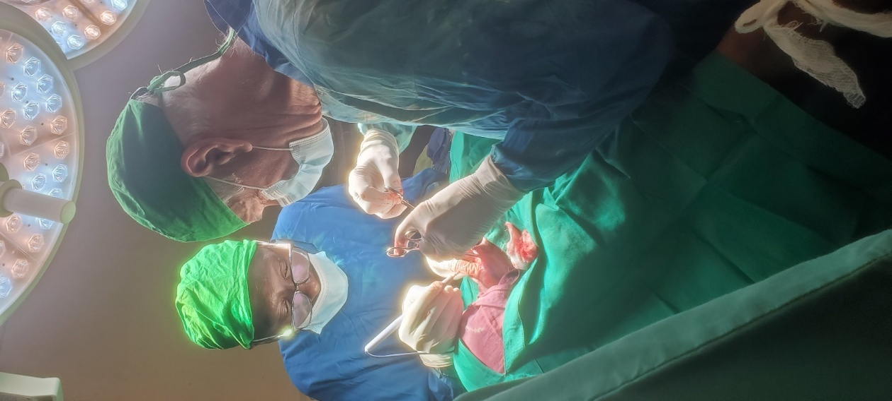 **Dr. McGee coaching Dr. ByaMungu.**

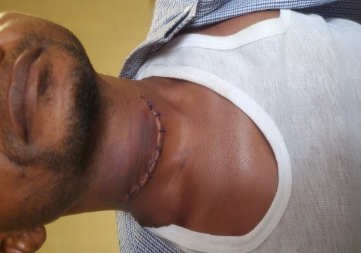

**Day two, post-operative, a patient is thankful for his surgical care.**

**Thanksgiving**

**Dr. ByaMungu** would like to thank the hospital administration and staff for the effort that they are making to improve the surgery service. The staff in the surgical department demonstrated a spirit of teamwork while serving the people. He also conveys his appreciation to Dr. McGee for his visit to Nundu which was a blessing to many. Dr. ByaMungu continues to be engaged in a pediatric surgery fellowship in Tanzania and comes to Nundu when his training schedule allows.

**Hope for the Future**

* Invite more visitors who may be coming to work with our local team
* Improve our laboratory for better diagnosis
* Improve our ICU for better critical care
* Advocate for more supplies while we have visitors

Thank you, Dr. ByaMungu, for providing the information needed to make this report available and casting a vision for the future.

**Support is Still Needed**

In the face of this conflict, we need more than ever your prayers and financial support. We cannot predict what impact this conflict will have on Nundu. However, we can say that the hospital staff is committed to providing care for a population which will have need more than ever for hope and a future. Yes, there has been civil unrest, even at Nundu. For the moment there is calm. The fate of Uvira, our main source of supplies and fuel north of Nundu, is still unknown.

Thank you, Champions for Congo! Your continued support is very much appreciated and critically important. We will keep you informed and will update our website as needed. For now, contributions to the general fund would be most appropriate. [www.congohealth.org](http://www.congohealth.org)

**Dr. McGee saying goodbye to Nundu and preparing for travel to Bukavu to meet with Bishop Lubunga.**

SHALOM, Tim Kratzer, Chair Congo Action Group

**Conflict Comes to DR Congo**

Dr. McGee met with Bishop Lubunga before his return to his home in Oklahoma City for the purpose of planning meetings with church leaders. However, at the same time, Goma, the provincial capital of North Kivu, was taken by what is known as the M23 rebel group. Since then, this same group has taken over Bukavu, the provincial capital of South Kivu and is moving south toward Uvira.

How do these events impact Nundu, located in South Kivu?

**Pray for:**

* Staff, supplies, financial resources and security at Nundu Hospital as they continue to provide essential medical care.
* Safety and security for ICCM projects including the students and staff at the Linda Stryker Academy. (International Child Care Ministries collaborates with Nundu in various projects.)
* A secure way to transport food, supplies and funds to the places where it is needed.
* Hundreds of thousands of people in need – displaced, injured, grieving, hungry and fearing for their lives and the lives of family members.
* God to act in such miraculous ways that the watching world will know He is Lord.
* That revival will move through this region of conflict which will result in racial and political reconciliation.