**NUNDU NEWS April 9, 2025**

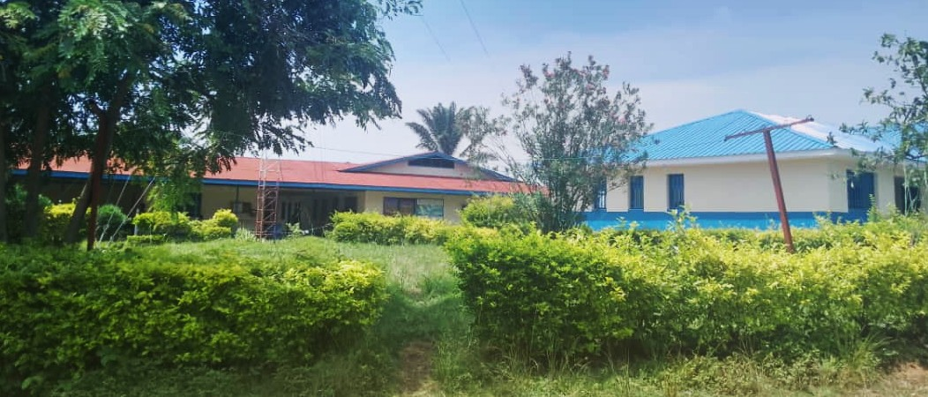

NUNDU DEACONESS HOSPITAL CAMPUS

**NEWS FROM NUNDU AND SOUTH KIVU**

From Dr. Luc, Director of COORMED (OFFICE OF MEDICAL COORDINATION), we have received news from our healthcare ministries in South Kivu.

* Nundu Deaconess Hospital reported 75 cases of M-pox in this period of conflict which is very critical given the fact that the hospital has limited resources to deal with this epidemic situation.
* In the area around Nundu there have been 135 cases of war injuries received and managed by the hospital, and among these war victims there have been 5 deaths.
* There are no NGO’s operating currently in our area, so medications and medical supplies have been running low in our facilities
* Some staff left their posts because of the war
* The Itombwe General Referral Hospital (in the high plateau region) has been devastated by military action.
* Tens of thousands of people have been displaced, and many houses destroyed

These are some of the emergency needs that we are dealing with.

**NEWS FROM NUNDU**

As reported in March, Nundu Deaconess Hospital continues to provide essential medical services for Nundu and the neighboring villages even as the conflict continues. Though the hospital has been able to receive medications and medical supplies from a pharmacy in Uvira, we are concerned that our line of credit will dry up if we are unable to pay off a $6000 debt. We were able to remit $1000 by MoneyGram, but then our account was disabled. With the banks throughout South Kivu still closed, we are looking for ways to get funds to our suppliers in Uvira as well as the hospital itself. The hospital staff continue to cope with limited resources and decreased incomes. We hope to have access to funds soon which will address this financial crisis. The mood in the village and among the staff remains calm but there is an unspoken concern for the future.

**STATUS OF THE WAR**

After the M23 took Goma and Bukavu in January and early February, they advanced south to Kamanyola, which is about one-fourth of the way between Bukavu and Uvira. They have remained incamped there for the past six weeks. We have heard about military action from that base connecting with other militant groups, but they have not yet made a direct attack on Uvira. Also, there has been military action in North Kivu, northwest from Goma. Thankfully we have been spared from open military action. Even as we have heard about combat elsewhere, the corridor from Uvira to Nundu is open, with “security” provided by a local militia group.

**NUNDU DEACONESS MEDICAL TEAM AT WORK**

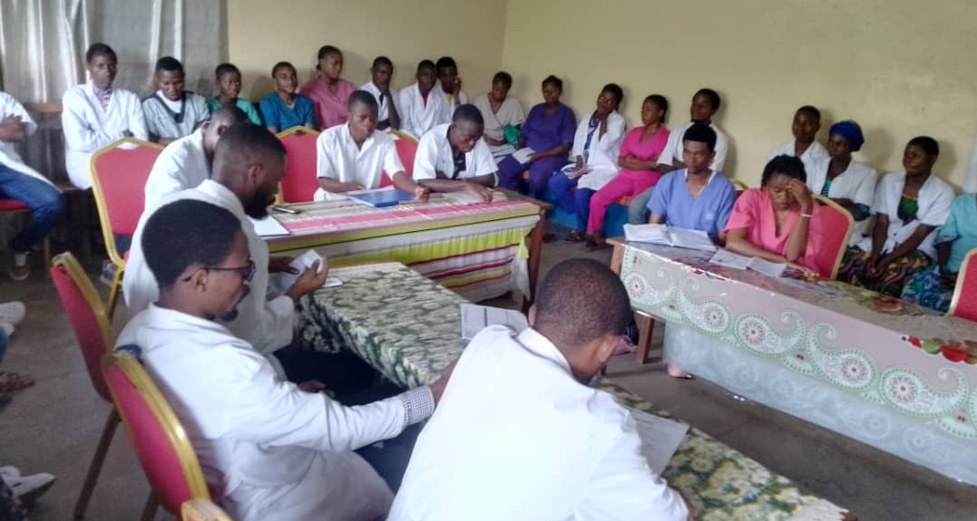

Morning report. The hospital staff are faithfully caring for patients even as they face an uncertain future.

NUNDU DEACONESS HOSPITAL STAFF PHYSICIANS

Ultrasound check, providing the best prenatal care possible with limited resources. All hospital services remain active- maternity, pediatrics, internal medicine and surgery. We are reaching a critical point where medications, medical supplies, and diesel fuel need to be replenished. Hospital staff need salary assistance so that they can provide for their families.

**ROADBLOCKS AND AN UNCERTAIN FUTURE**

The needs of our medical team at Nundu and throughout South Kivu have been on my mind. Given the many roadblocks that we have experienced in trying to get humanitarian assistance to DR Congo, I have had to go back in prayer to confess that I was trying to control what I cannot understand.  I have allowed frustration to take the place of faith.  But there has been good news, giving us an opportunity to regroup and agree on the way forward.

One roadblock is simply transferring funds to our supplying pharmacy in Uvira.  Many attempts to make payments by MoneyGram have failed.  We have not given up and we will find a way.

The next roadblock has been having access to bank accounts from which we would be able to access dollars.  We now have three accounts which will serve ICCM, NDH, and FMC-DRC.  When and how should these accounts be managed?  An option for Bukavu would be to collaborate with ALARM, Africa Leadership and Reconciliation Ministries, a collaboration which will enable us to provide humanitarian aid as well as resolve tribal conflict and offer trauma informed care.

Finally, we have been working on creating a team which can work together in making the needs arising from this conflict known and addressing these needs.  Leaders in DR Congo and here in the US have agreed on a "Crisis Management Initiative."  We have formed a Crisis Management Team which will work together in providing humanitarian assistance as well as lay the groundwork for reconciliation. While this conflict has put us off the course we had envisioned, we know that the Lord has a plan and a purpose going forward.

Here is how Dr. Marx, my friend and colleague, has responded to my concerns: I am happy to read (about) your reflections on many aspects and letting faith take the place of frustration.  There is a lot going on in the world right now and in our individual lives. But as I understand from your reflections, let us submit ourselves to God. HE will lead our steps. During time of confusion, darkness and a lot of uncertainty; rely on God, only God can give us His light and show us the right path to take.

**CONTINUE TO PRAY FOR:**

* The provision of medications and essential supplies for Nundu Deaconess Hospital, other hospitals, and health centers as they continue to provide medical care.
* Staff as they provide for their families with decreased incomes and a shortage of food.
* The Crisis Management Team as we attempt to address humanitarian and spiritual needs.
* That revival will move through this region of conflict which will result in racial and political reconciliation.
* Success of proposed peace talks between M23 and DR Congo leaders. The peace talks that were to be held in Angola March 18 never took place. However, there are reports that there is ongoing dialogue which we pray will result in peace and reconciliation.

We urgently need your prayers and ongoing financial support as we face an uncertain future. Though the flow of funds has been interrupted, the need for financial assistance continues. As reported, we are working on ways to send funds to our friends and medical ministries in the region. But more importantly, we need your prayer support as we ask our Heavenly Father to soften the hearts of those who have found themselves in conflict.

Tim Kratzer, Chair of Champions for Congo [www.congohealth.org](http://www.congohealth.org)