**Nundu News September 18, 2024**

**Congo Connection 2024**

**Our time at Nundu came to a productive conclusion August 13. With the completion of the solar upgrades in July (see newsletter,** Nundu News July 21, 2024) **we focused on gathering data and information for a grant request to build a midwife classroom building.**

**ITM Nundu Expansion - The Need**

Maternal-child health is an urgent concern, with excessive maternal-child deaths being reported in South Kivu, the province in which Nundu Deaconess Hospital (NDH) is located. Construction of a classroom building to increase and upgrade the capacity of ITM Nundu (School of Nursing) is urgently needed to train midwives to address this issue affecting our population.

**Kayande, Director of ITM Nundu, Isumbelo, secretary, and Ruth Sloman planning for ITM Nundu’s expansion.**

**History**

ITM Nundu was established in 1987 to train nurses to serve at NDH, the reference hospital for the Nundu Health Zone. At its inception, the school functioned as a two-year training (A3) program within the hospital complex and in 2001 transitioned to a four-year (A2) program. In 2008, it was determined by the government that ITM Nundu needed its own building. The four classrooms, offices, and library constructed with the assistance of Free Methodist World Missions in 2010 initially served well the ITM mission, but now are inadequate for the expanded mission of training midwives.

**Impact on Healthcare**

Since 1987, ITM Nundu has trained 384 nurses, 94 of whom work in health structures in the Nundu Health Zone and 64 work in health structures outside the Nundu Health Zone, but in the province of South Kivu. Of these, only 10 are midwives. ITM Nundu graduates occupy various positions where they are making major contributions, significantly reducing morbidity and mortality.

**NDH neonatal intensive care unit.**

**Maternal-Child Health**

In 2015 the Nundu Health Zone determined that there were excessive maternal-child deaths in the health zone. It was recommended that trained birth attendants be recruited. Since the need for trained midwives exceeded the number of midwives available, it was recommended that ITM Nundu open a midwife section. In the 2016-17 school year, this section was opened to train midwives at the A2 level, but with no increase in the number of classrooms. The first midwife to graduate was in 2020 and to date there have been 10 midwives graduated.

**Impact of Trained Midwives**

The number of qualified midwives is still insufficient. There are trained birth attendants in only 35% of the health centers in the Nundu Heath Zone. Midwives are assigned where the need is the greatest, with a goal of two birth attendants per primary care facility and more per secondary care facilities. Health centers in neighboring health zones of South Kivu report the same need. With the training of midwives, the need for qualified midwives will be addressed over the next five years as we hope to see 67 midwife graduates. Assisted deliveries monitored by skilled birth attendants will increase, with corresponding decrease in maternal-child morbidity and mortality.

**Summary - Impact**

Construction of the Midwife Classroom Building will enable ITM Nundu to provide the learning environment for nurses and midwives who will provide holistic care which is transforming. Adding four classrooms and two offices will allow space dedicated to the midwife track, both for lectures and facilitating after-hours study and tutoring.

**Proposed midwife classroom building, center and left.**

**Next Steps**

This project is the first step in upgrading the training capacity and effectiveness of ITM Nundu. The ITM leadership has identified the following opportunities:

* Recruit qualified students while providing scholarships as needed.
* Address the academic preparedness of students as it relates to language, math and basic sciences.
* Establish a reliable internet connection, thus providing access to current information.
* Establish university partnerships and offer scholarships to teaching staff to pursue advanced degrees.
* Encourage the teaching staff by improving salaries and providing in-service opportunities.

**You Can Get Involved**

A committee will identify higher achieving students and students with financial need. Scholarships will be funded by you, our donors - $360 will support a student for one year, or $360 will support a teacher for one month. You can support ITM Nundu by giving through our website [www.congohealth.org](http://www.congohealth.org) (indicate ITM Nundu Scholarship or teacher support).

**ITM Nundu students.**

**Here is what Dr. Marx reports:**

*Decades of conflict in Eastern Congo have impacted all sectors of life, resulting in a fragile economy and poor health. Also, epidemic and endemic diseases have slowed efforts to improve health outcomes. Women and children are the most affected.*

*According to the research group EQUAL, “Women living in Sub-Saharan Africa are fifty times more likely to die during pregnancy and infants are ten times more likely to die in their first month of life, compared to those living in high-income countries. Those most at-risk live in countries affected by humanitarian crises, which account for almost half of all newborn deaths* *and more than 60% of all maternal deaths worldwide.” (equalresearch.org)*

*Nundu Deaconess Hospital is committed to aligning with the national policy of reducing maternal mortality while facing challenges of life in Eastern Congo.*

**A VISION FOR THE FUTURE**

Dr. Marx has provided visionary leadership for Nundu Deaconess Hospital since being appointed medical director in 2018.

Dr. Marx is a creative leader, taking Nundu to new levels. He is an innovator. In following his passion for maternal-child health, he has established the neonatal intensive care unit. He is a connector, reaching out to bioengineering specialists in Bujumbura to assist in maintenance of hospital equipment. He is a role model, dedicated to family and the Lord. He is a motivator, encouraging the staff to be all they can be by offering healing through trauma-informed care.

**

**Dr. Marx, Christine and family. Neema the new arrival.**

**Dr. Luc Mmebwa Joins the Team**

Dr. Luc completed OB/GYN training in June and now serves as director of the Office of Medical Coordination for the Free Methodist Church DRC. He has provided valuable insight in how we can provide training of the highest quality for our nurse midwife students. He also assisted the team as we agreed on how the ITM Nundu expansion will be funded and implemented. He will visit Nundu on a regular schedule to provide surgery services, assisting our physicians in routine surgeries as well as doing more complicates surgeries. He is part of a bright future for healthcare in South Kivu. His wife, Irene, and family live in Bukavu.

**Tim and Connie Kratzer with Dr. Luc and his wife, Irene.**

**Kratzer’s Nundu Departure**

**Kratzer Soccer Classic**

Our two-month mission to Nundu wrapped up as it began, with a bumpy ride over rural roads and a boat ride. But before Connie and I said good bye to our Nundu friends, we were honored with what was called the Kratzer Football Classic, put on by Nundu Deaconess Hospital players and community team.

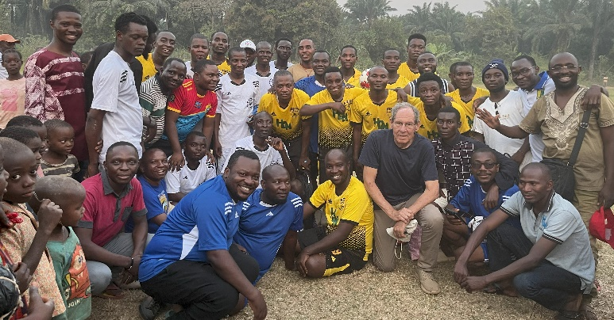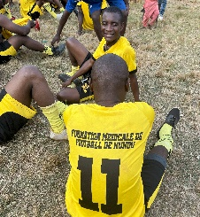 **Nundu Deaconess Hospital team.**

**Traveling to Bujumbura**

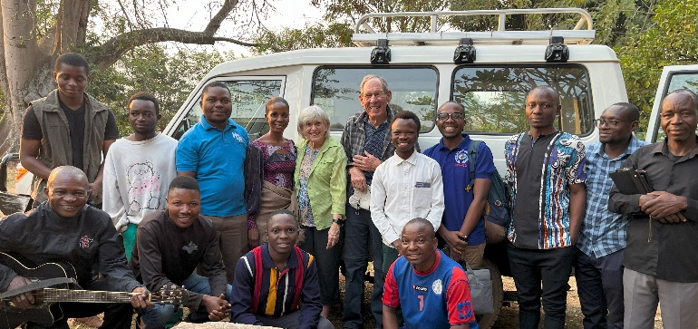

**Saying goodbye, Nundu friends and travel companions.**

After arranging the group for the traditional “saying goodbye” photo, we find our places in the Toyota Landcruiser for the ride north. The Cape to Cairo highway remains under water north of Nundu. At the end of a short but bumpy ride, we board a boat to continue on our way to Bujumbura.

**Drs Marx and Christian with Connie.**

**Visit with Nundu Friends in Bujumbura**

After a safe arrival in Bujumbura, we visited our Nundu friends - Dr. Marx’s family, Dr. Baron and family (a recipient of a scholarship to support him and family as he continues in an OB/GYN residency), and Dr. ByaMungu’s family. Dr. ByaMungu is heading back to Tanzania to continue a pediatric surgery fellowship, after spending two weeks at Nundu taking on our more complex surgical cases.

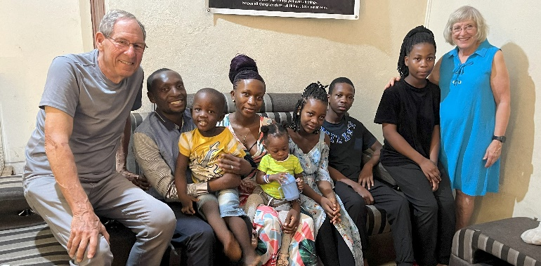

**Dr. ByaMungu with his extended family in Bujumbura.**

**Mission Accomplished**

We arrived at Nundu June 17 and departed August 13, having experienced life at Nundu once again. … rounding with recent medical school graduates assigned to Nundu for clinical training. … meeting with representatives of the 53 healthcare ministries of the Free Methodist Church DRC. … finishing the Hadduck House rehab. … hosting the I-TEC team as they completed solar upgrades. … hosting the ICCM team as we explored the opportunity to form an academy of excellence. … hosting Ruth Sloman, a UK nurse midwife, as she reviewed our NDH maternity protocols and plans for expanding the Nundu School of Nursing. … working with builder and engineer Paul Ikocha and Habibu as they supervised the maintenance team.

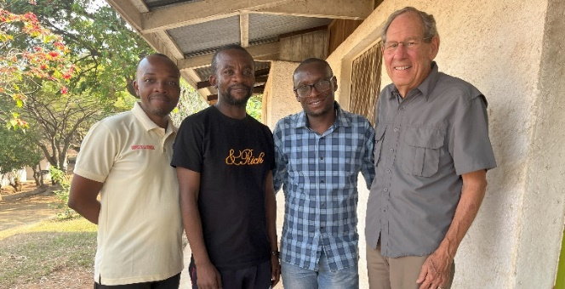

**Drs Marx, Luc, ByaMungu, and Kratzer.**

The leadership team is planning for the future of healthcare at Nundu Deaconess Hospital and its allied health care ministries. Stay tuned for more news and opportunities to become involved. Thank you for your financial support and prayers.

Tim and Connie Kratzer September 2024 www.congohealth.org