GIVING THANKS FOR YOUR SUPPORT AND THE LORD’S PROVISION
Champions for Congo News – November 29, 2022

GIVING THANKS
We praise God for the many ways in which he has provided for the ministry of Deaconess Nundu Hospital. Thank you for your prayers and financial support.

Butterfield Memorial Foundation (BMF) is partnering with DNH to triple the size of our solar plant, which was installed in 2018. The Foundation joined us in funding that first installation and is now partnering with DNH in providing a generous $200,000 grant. The total cost of this project will be $307,027. Beyond the $200,000, individual donors have contributed. Thank you for supporting this critically important project. In addition, International Technical Electric and Construction (I-TEC) volunteers will build the system in Montoursville, PA and send engineers to travel to Congo next summer to install the power plant upgrades.

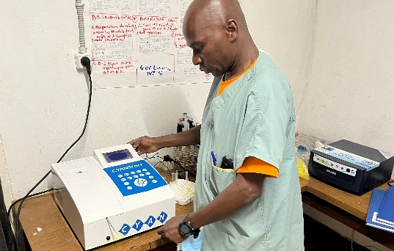
Lab powered 24/7

DNH is a center for hope and healing, providing healthcare that transforms, a light in the darkness. A reliable source of power provides an environment where an underserved population is treated with respect and dignity. That Deaconess Nundu Hospital remains a beacon of God's light and healing despite enormous challenges is a testimony to the resilience and dedication of the staff along with God's provision. With this investment in the hospital’s infrastructure, DNH will continue to be a center of excellence serving as the hospital of reference for 21 healthcare centers in the Nundu Rural Health Zone.

Scholarships are providing the trained staff needed. As recently reported, Dr. Byamungu has completed a surgery residency at Kampala International University (KIU). He is now returning to Deaconess Nundu Hospital in keeping with his call to serve the underserved. He has been supported in his medical school and surgery residency by the generous support of several Champions.
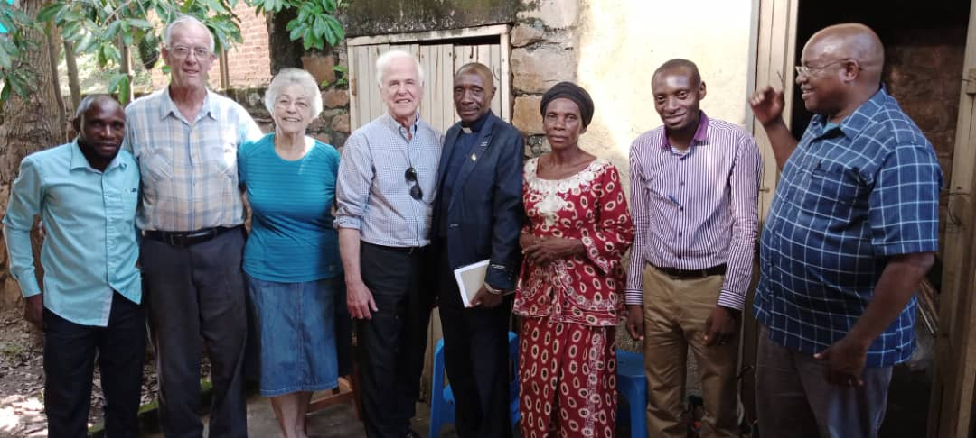
Dr. Byamungu, family and friends
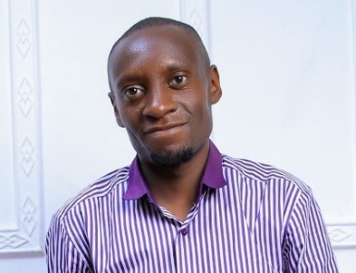
It is a blessing to realize that DNH which serves over 300,000 people will now have a trained surgeon, the only surgeon in the region. Another surgeon is in training. Dr. Luc is a scholarship recipient in his second year of OB-Gyn residency. Complicated cases, surgical and obstetrical, will receive the best of care as patients are referred to the hospital from healthcare centers.

Dr. Marx Itabelo Lwabana, the Medical Director at Nundu Deaconess Hospital has been providing leadership in uncertain times. The Lord has called him to serve the most vulnerable. Dr Marx is currently an Atlantic Fellow for the health equity program offered by George Washington University. His focus is improving mental health capacity by integrating mental health screening and management. He is also devoted to excellence in his professional development, having completed with distinction the Executive Health Leadership Master’s Program of Brown University.
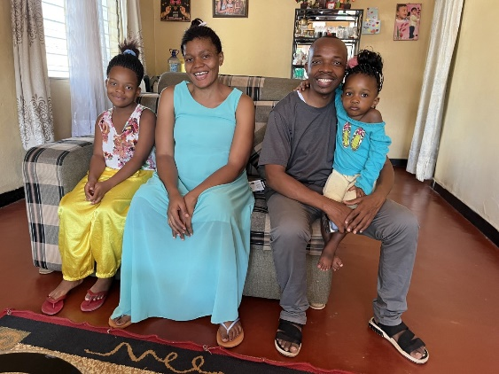
Dr. Marx and family
Dr. Marx graduated from the Official Government University of Bukavu in 2009. After gaining clinical experience at Deaconess Nundu Hospital, he accepted a position in the Frank Ogden School of Medicine (HAU) in Bujumbura. He was called by Bishop Lubunga of the Free Methodist Church of DR Congo in 2018 to serve at Nundu. When we visited Nundu in June we saw a compassionate, competent physician leading the staff in a quiet, unassuming manor.

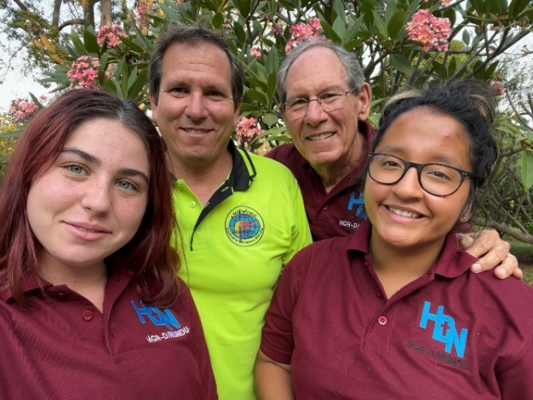
We, Ken, his two daughters Lupita and Savannah, and I, give thanks for the opportunity to visit the Congo in June. As we toured the hospital as well as visited other healthcare centers, we were amazed by the enthusiasm and commitment of the many healthcare professionals serving with limited resources. What we find most remarkable is the multiple healthcare ministries established by the Free Methodist Church – the church oversees 53 healthcare ministries, including four hospitals, with 21 doctors serving the church. The total number of healthcare professionals and workers is 453. The area served is immense with a population I would estimate to be around 600,000. These providers perform minor surgeries, maintain immunizations, respond to epidemics as well as provide care for endemic diseases such as tuberculosis and AIDS. The church is committed to Healthcare that Transforms.
PRAYERS AND FINANCIAL SUPPORT ARE NEEDED
The poverty of the population served by Deaconess Nundu Hospital could be overwhelming, but the people have a quiet resolve to champion change. The Free Methodist Church of the DR Congo is inviting all who will to join them in their journey, assisting in whatever way possible. In many cases, our patients are unable to support the cost of healthcare, so your support is critically important.
Champions for Congo is making a difference by supporting the following projects:
Medication Fund $1000/mo
Patient Care Fund for families who are unable to pay hospital fees. $1000/mo
Nutrition Program, especially important when families have limited resources. $1000/mo
Salary Supplements $2400/mo
Maintenance Team Support $825/mo
Diesel fuel to supplement solar power $600/mo
Would you consider joining those who are making a difference? As we come down to the end of 2022, we urgently need donations to the Medication Fund, Patient Care Fund, and Nutrition Program. We also need donors who would pledge to help cover the salary of Dr. Byamungu, which we are expecting to be $900/mo. He has requested that the inventory of surgical instruments be updated, which will be another expense. He is returning to Nundu to serve the underserved, so let’s support him in whatever way possible.

You can donate by going to our websites:
www.congohealth.org or www.gocaho.org.
or you can send a check to:
CAHO, PO Box 580, Spring Arbor, MI 49283
Also, please consider sharing this information with friends who may want to pray and perhaps give.

If you want more information or have questions, please e-mail timothykratzer@hotmail.com or normwetterau@aol.com.
Perhaps you would want to give us a call. We would value the opportunity to talk with you.
- Tim Kratzer (520) 390-3402
- Norm Wetterau (585) 705-8811

THANK YOU, FAITHFUL CHAMPIONS!
Thank you for joining us in this journey as Nundu and surrounding villages experience Healthcare that Transforms. You are making a difference. Your contributions to assist patients who would otherwise not be able to pay for their hospital care are urgently needed. You are providing hope and a future. Imagine the lives that will be saved for every $100 you give …
- ten new borns off to a healthy start
- four children treated for malaria
- two patients recovered from major surgeries

Blessings, Tim Kratzer

