NUNDU NEWS April 2021
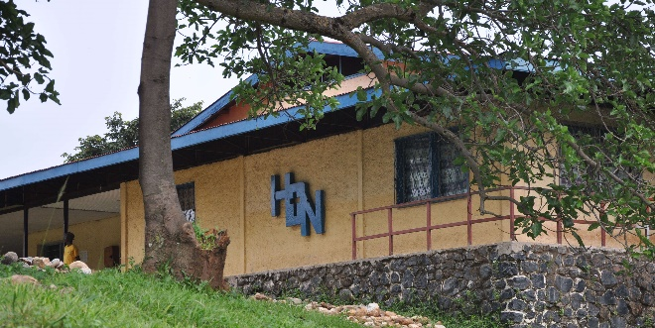
DNH Hospital Encourages and Rewards Staff for their Years of Faithful Service
Located in a rural, impoverished region, Deaconess Nundu Hospital (DNH) struggles to survive. Dr. Marx reports that if the hospital were located in a city where the population would have funds to support their medical care, the hospital would be able to provide living wages. Thanks to private donations, we are able to supplement staff wages. Here are hospital staff testimonies giving thanks for this generosity.
Mihigo Issa David, Nurse in Peds
I present my gratitude for the support we are receiving. Thank you for your generosity.
I am the head nurse in pediatrics. I have five children and support four more children from another family member. The local salary I am receiving varies but has never been sufficient to cover family needs. The supplement salary I receive from CAHO helps me feed my family. Many thanks.
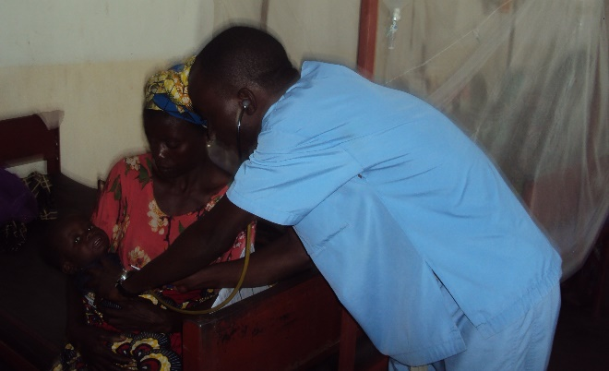

Alaka Mwenemkamba, Outpatient Nurse
The supplement support I receive helps a lot to cover the school needs and other needs for my family. I am feeding eleven people under my responsibility. You will understand that it is always difficult for me to connect the two ends of the month. My wife works hard cultivating cassava, giving us cassava leaves and flour. I spend most of my days at the hospital and have limited time to do other things.
All what I can say is that Almighty God who created the earth and heaven bless you abundantly to keep this support for many more years.
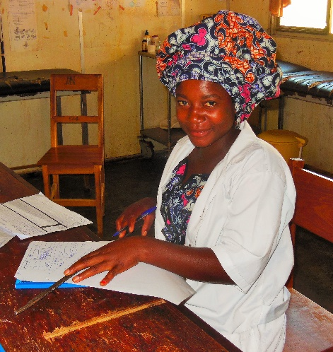

Rahabu Emedi, Receptionist
Receive our warm greetings in the name of Jesus Christ. Thank you for the great work you are doing, supporting us financially and in various other ways (patient care, pharmacy, and nutrition projects). The salary supplement I receive helps me cover the needs of my children for school feeds and their food. My husband has a job in a small nonprofit organization, and together we support our children. Even with my husband’s support, when we decided to send our daughter to university, we found ourselves struggling. Thank you again for your generosity. It means a lot to us.
Join the Team
You can be a part of the hospital staff by contributing to the staff salary support fund. When Jerry and Lilly Ann Rusher were a part of the medical team in 2014, they saw the need of the staff to be better able to provide for their families. (Doctors’ salaries were already being supplemented by a separate fund.) They put their concern into action by establishing a non-physician staff salary support fund. This fund has been providing on average about $20/mo, bringing the total average salary up to about $100/mo. We would like to increase this amount and thereby address the needs of a growing staff.
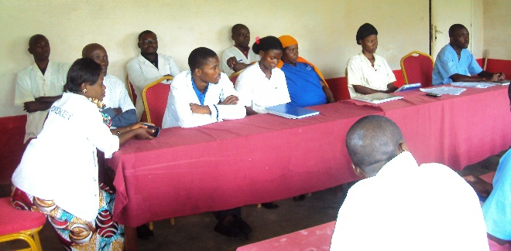
You may not be able to visit Nundu in person, but you can be a part of the team by joining in providing salary support. We already have $600/m pledged. Twelve people giving $50/m would enable us to reach our goal of $1200/m.
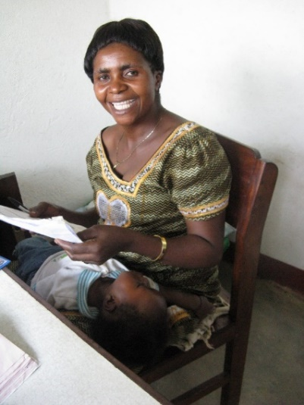

Dr. Marx, Medical Director, Now in Bujumbura
In December we reported that the borders with Rwanda and Burundi were closed. Dr. Marx had not seen his wife Christine and family since March, 2020. As we previously reported, his second daughter Na’yenge Itabalo Elsie had been born on April 28. Late in December Dr. Marx was able to cross over into Bujumbura, Burundi. The borders are once again closed, so he remains in Buja with his family. Though happy to be with his family again, Dr. Marx is anxious to get back to his work at Nundu. He continues to address administrative issues remotely.

Dr. Christian Directing DNH in Dr. Marx’s Absence
ASSUMANI M’MBONDO Christian, MD, has been chief of staff since January 2020. He joined DNH in June 2018, from Centre Hospitalier (CH) NAKIELE, a FMC healthcare center, where he had been medical director since May 2017.
Before CH NAKIELE, Dr. Christian served with Medcin San Frontier (MSF) for three years, gaining valuable clinical and administrative experience. Dr. Christian had done his clinical training at Hopital de BARAKA, for six months before joining the MSF staff.
He holds a medical degree from Universite Evangelique en Afrique, 2012 and Secondary School diploma from Institut Mgr. BYAENE in Bukavu.

Solar System Restored
Back in 2020 the acid-based batteries of our solar system were found to be failing, putting a strain on the back-up diesel generator. Then the diesel generator went down, and the hospital was at risk of being entirely without electricity. Our local maintenance staff stepped up to get the generator back on-line. We then contracted with GoShop, an international company which has a regional office in the DRC, to provide urgently needed technical assistance. Matt Aungst with I-TEC served as liaison between GoShop and the staff at Nundu to sort out what was needed to repair and service the diesel generator. While all this was happening, Matt was assisting us with the purchase of an eight-battery lithium power back. The same company, GoShop with its international office in Brussels, was instrumental in getting the lowest price for purchase, shipping and installation. This was all an answer to prayer, coming right down to the end when final delivery of the batteries was delayed because of flooded roads. Final delivery by boat was arranged and successful.
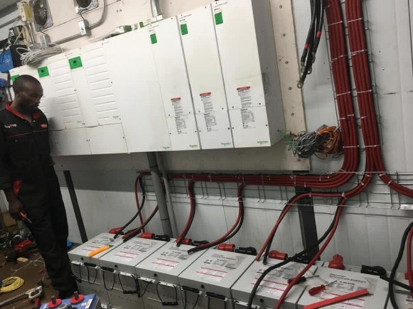
I-TEC again stepped up to supervise the final installation of the batteries, thanks to internet connections. The system is now functioning as designed, producing most of the energy needed from the sun.
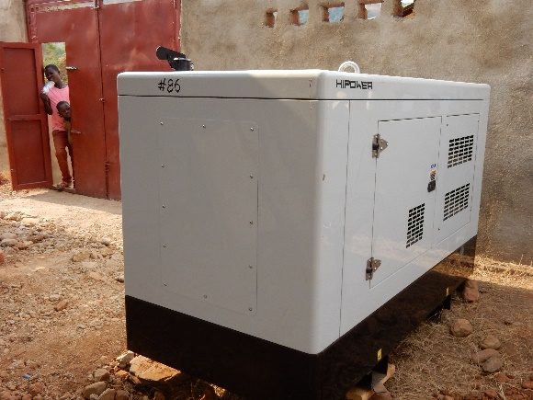
The diesel generator is fully serviced and now operating in back-up mode as designed.
The replacement battery pack is guaranteed for 10 years. The total cost of this project will come to about $50,000 and was covered by a grant from the Young Foundation.
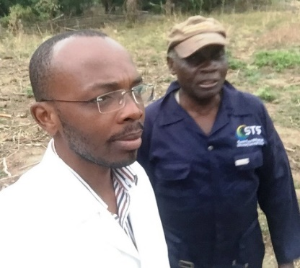Dr. Marx with Habibu, who was part of the team which serviced and repaired the generator.

SUMMARY OF PROJECTS IN URGENT NEED OF SUPPORT
- Staff Salary Support
- Pharmacy Fund
- Patient Care Fund
- Nutrition Program
Thank you for your continued prayers and financial support. Contributions can be sent to CAHO, PO Box 580, Spring Arbor MI 49283-9986 or through these websites, www.gocaho.org or www.congohealth.org.

