NUNDU NEWS 2020
December 2020
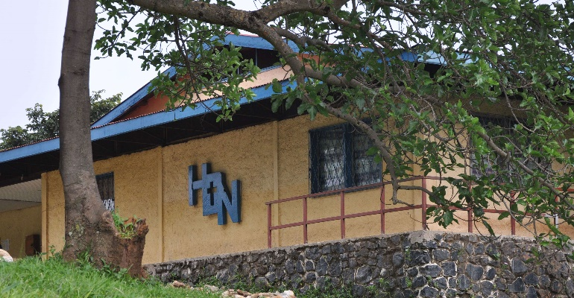

Malaria an Endemic Disease
Taking More Lives Than CoVID-19
A British Medical Journal article stated that in Sub-Saharan Africa more than 400,000 children die of malaria each year which is more than the than those people of all ages who have died of Covid-19. Of the 30,000 who have died of the corona virus, two-thirds lived in South Africa. Due to coronavirus some mosquito control programs have been on hold which means there will be more malaria and less treatment. It is estimated that there may be up to an additional 50,000 deaths of young children from malaria in Africa this year.
Deaconess Nundu Hospital sees hundreds of cases of malaria in children. Without treatment death often occurs. Inpatient treatment children with malaria can cost between $25 and $50. Many parents are afraid to take their children to the hospital because of the cost. Generous donors have enabled the hospital to buy medicines and help with medical bills. Please consider a gift to save children’s lives from this treatable disease.
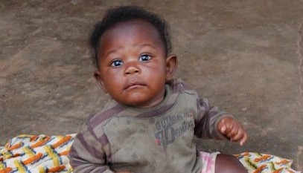
Thank you for your continued prayers and financial support. Contributions can be sent to CAHO, PO Box 580, Spring Arbor MI 49283-9986 or through this website, www.gocaho.org or www.congohealth
COVID-19 pandemic impacts nundu
Dr. Marx reports that though they were concerned about the COVID-19 pandemic, they have seen no cases at Nundu. In March the capital Kinshasa was in lock down and people were not allowed to travel to the provinces. All the schools were closed, and no gatherings of more than 20 people were allowed. Burundi and Rwanda closed their borders with Congo in late March.
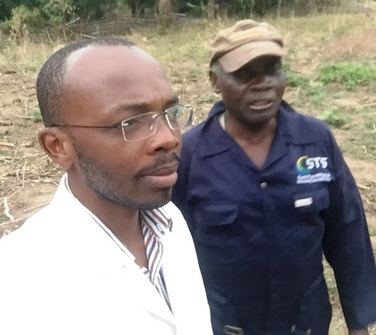
Dr. Marx, Medical Director of DNH, and Habibu oversees maintenance.
During this period, Deaconess Nundu Hospital was facing a Cholera outbreak. Its twelve cholera isolation beds were not adequate for 15 to 18 patients per day under treatment. Pharmacy stock was running low. Thank you for your contributions to the pharmacy fund which enabled the hospital to replenish medicines.

Since there were a only a few cases of Covid in the provincial capital of Bukavu at the end of May, the lockdown of the city was lifted. Even though markets were opened at Nundu, prices of goods which come from Bukavu and Uvira were inflated.

With all the challenges that the DRC is facing, Dr. Marx remains focused on the spiritual impact of the medical program. He has a vision of the hospital staff impacting the lives of their patients as they devote their lives to serving God.

The Patient Care Fund a life saver
The Patient Care Fund has had a significant impact on the patients at DNH. Baruani is a four year old, living with sickle cell disease, a disorder of the blood caused by an inherited abnormal hemoglobin. Many children with Sickle Cell Anemia are hospitalized more than once a month, often needing more than one blood transfusion. His father expressed gratitude for the Patient Care Fund, saying that this was his son’s 53rd admission. Since the hospital bill was paid, he felt a burden lifted.
Baruani is one of many children benefiting from the generous people supporting this fund. DNH provides healthcare for the under- served population of the rural of South Kivu Province. The population is extremely poor, living on less than a dollar per day. This region has experienced repetitive political unrest. The DRC is in its recovery period, so the hospital is heavily dependent on external donors. There is no health insurance, so patients must pay for their hospital care themselves. However, most of the population in the area cannot afford hospital care and prefer remaining at home while trying different traditional medicines. They only visit the hospital in more desperate conditions, which explains the high mortality rate. In some cases, patients with limited resources tend to leave the hospital before their children are completely healed. They even avoid returning to the hospital when the situation worsens at home, increasing child mortality rate in the community.
Many children are dying of malaria because they are not brought to the hospital early on in their illness. Zawadi is a one year old who was referred to the hospital with severe malaria and anemia in need of a blood transfusion. Her mother knew that she had no money for hospital fees and asked the nurse to keep the baby at the health center. However, an ambulance was called transport the child to hospital and treatment was begin immediately. Six days later Zawadi was ready for discharge. The mother was informed that the $25 hospital bill was covered by “people of BONNE VOLONTE.” Tears of joy flowed and praise to the Almighty was offered.
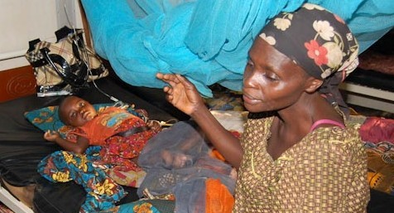
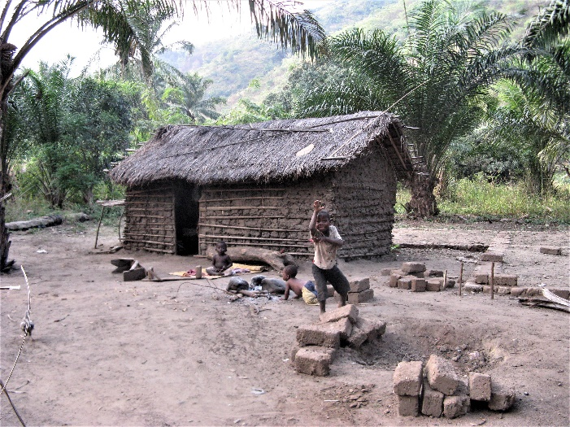
The population of South Kivu is extremely poor, living on less than a dollar per day. This region has experienced repetitive political unrest and economic instability. The Patient Care Fund was initiated to help vulnerable children receive the medical care they need to survive. This fund has proven to be effective in improving outcomes as well as stabilizing the financial health of the hospital.

Making a Difference through
Better Nutrition

Dr. Marx has prepared a PowerPoint posted on this website which describes the impact of the nutrition program at Nundu. The provision of a high protein energy rich porridge is very much appreciated by the patients. Maintaining this service is making a difference in patients’ lives. Here is the story of one mother and her baby daughter as reported by Dr. Marx.

Jeanine is a mother of six, including a baby boy of 3 months, living in the Lusenda refugee camp with her husband and their children. The infant was referred to the hospital for malnutrition in early October. It was clear that the mother had suffered low breast milk production because she was herself malnourished.
The little baby was admitted to the nutrition unit, receiving therapeutic milk, and the mother received our healthy porridge (soja, sorghum, maize, oil and sugar) twice a day. The baby had a birth weight of 3.5 kg and at admission weighed only 4 kg. After eight days of treatment at Deaconess Nundu Hospital the baby had gained 0.5 kg.
The baby’s general good condition was improving, and the mother had increased breast milk production. I was contacted by the nurse in the hospital for a discharge

plan. My greatest fear was to see this mother back at the hospital in the same condition. I felt the need to do something to help her at home even though we have not been sending nutrition supplements home with every patient. We decided send our healthy porridge home with the mother.

Dr. Marx goes on to report that the positive experience with nutrition supplements is opening a path to a new program, “Women in Community Program.” He has appointed staff to help follow up the cases that leave the hospital in an improved state in order to follow their progress and measure the success of this project. Thank you, Dr. Marx, for your passion and vision for this new project.

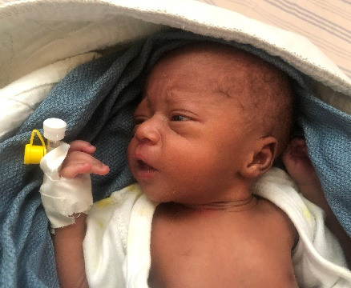

Na’yenge Itabalo Elsie JOINS THE MARX FAMILY

The borders with Rwanda and Burundi are still closed. Christine (the wife of Dr. Marx) and his daughter have been getting along on their own in Bujumbura. They are able to able to maintain contact with Dr. Marx by Skype and email. Here is the good news. Christine delivered on April 28, a healthy girl Na’yenge Itabalo Elsie. From all reports, Elsie is doing well. Though this is good news, as of this date Dr. Marx has not seen his new daughter. Pray for Dr. Marx and Christine during this time of separation.
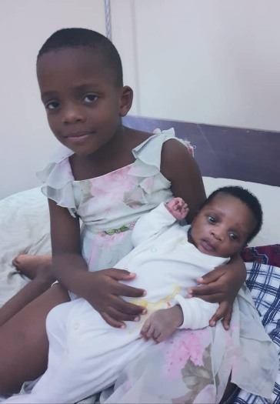
Newborn Elsie bonding with older sister Esther.
SOLAR POWER TO BE RESTORED
In August we began consulting with I-TEC regarding the apparent failure of the battery pack for the solar installation at Nundu. (Shown below.) We were able to purchase and ship lithium batteries from Brussels. This replacement battery pack is guaranteed for 10 years and will be arriving this month. The total cost of this project will come to about $50,000 and was covered by a grant from the Young Foundation.
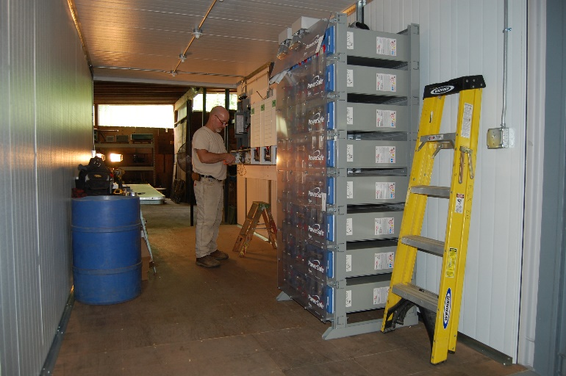

SUMMARY OF PROJECTS IN URGENT NEED OF SUPPORT
• Maternal and Newborn Health
• Patient Care Fund
• Nutrition Program
Thank you for your continued prayers and financial support. Contributions can be sent to CAHO, PO Box 580, Spring Arbor MI 49283-9986 or through this website, www.gocaho.org or www.congohealth.org.

